ZAMBIAN WAYLEAVE CODE OF PRACTICE 2021

DRAFT REVISION 1
(For comments)

FOREWORD

TABLE OF CONTENTS
FOREWORD i
Table of figures v
Table of tables vi
Abbreviations and acronyms vii
Definitions viii
1 Introduction 1
1.1 Purpose of the Code 1
1.2 Scope of the Code 1
1.3 General provisions, specifications and requirements of the Code 1
1.4 Application of the Code 2
1.5 Waiver of specifications and provisions 3
1.6 Intent and interpretation of the Code 3
1.7 Effective date of the Code 4
1.8 Units of measure used in the Code 4
1.9 Method of calculation and measurement 4
2 Minimum Wayleave and Clearances 5
2.1 Minimum Wayleave in urban and rural areas (general) 5
2.1.1 Wayleave width 5
2.1.2 Minimum and maximum distance between outer conductor and the edge of Wayleave width 5
2.1.3 Minimum Clearance from Transmission or Distribution OHL conductors to tower structure 6
2.1.4 Spacing of Transmission or Distribution OHL conductors 6
2.1.5 Calculation of Wayleave width for Wayleaves containing more than one Transmission or Distribution OHL 7
2.2 Minimum Wayleave in recognized Forestry areas 12
3 Minimum permanent Clearance from conductors of Transmission and Distribution OHL near structures 13
3.1 Important Notes on the Section 13
3.2 Vertical Clearance above ground 13
3.3 Vertical Clearance above buildings and structures classified as buildings 14
3.4 Lateral Clearance near buildings and structures classified as buildings 14
3.5 Vertical Clearance above structures not classified as buildings 15
3.6 Lateral Clearance near structures not classified as buildings 16
3.7 Vertical Clearance above bridges 16
3.8 Lateral Clearance near bridges 17
3.9 Vertical Clearance of OHL crossing above roads, alleys and parking lots 17
3.10 Vertical Clearance above rail track or railway 19
3.11 Lateral Clearances near rail track or railway 20
3.12 Vertical and Lateral Clearances near aerial telecommunication line 20
3.13 Vertical Clearance above water level in swimming pool or above walk way around swimming pool, diving platform, tower and water slide or other fixed, pool-related structures 21
3.14 Lateral Clearance near edge of swimming pool, walk way around swimming pool, diving platform, tower or water slide or other fixed, pool-related structures 21
3.15 Height for attaching Overhead Service Line to building or structure 22
3.16 Vertical Clearance above an above-ground or underground infrastructure used for storage or handing of flammable substances 24
3.17 Lateral Clearance near underground and above-ground infrastructure used for storage or handling of flammable substances 24
3.18 Vertical Clearance above navigable and non-navigable water bodies 25
3.19 Clearance between conductors of different OHL circuit on the same support structure 27
3.20 Lateral Clearance between conductors of different OHL circuit on different support structures 27
3.21 Vertical Clearance between conductors of different OHL circuit on different support structure 28
3.22 Clearances to Transmission and Distribution OHL in the vicinity of solar PV farm 29
3.23 Clearances to Transmission OHL in the vicinity of wind farms 30
3.24 Clearance to Transmission and Distribution OHL in the vicinity of explosive magazine and quarry blasting 31
3.25 Clearance to Transmission and Distribution OHL in the vicinity of fire hydrants located outside buildings 31
3.26 Clearance to Transmission and Distribution OHL in the vicinity of trees and hedges 31
3.27 Clearance to Transmission and Distribution OHL in the vicinity of street lighting 32
3.28 Clearance from Transmission and Distribution OHL to other objects and spaces (general) 33
4 Minimum safety Clearances when working near Transmission and Distribution OHL 35
4.1 Important Notes to the Section 35
4.2 Definitions related to section 4 35
4.3 Safety distances to maintain on sites where there will be no work or plant passing in or under the Hazard Zone 38
4.4 Safety distances to maintain on sites where plant and machinery will pass under a live OHL 39
4.5 Safety distances to maintain on sites where work will be carried out in the Hazard Zone 40
4.6 Safety Clearances to maintain when performing road strengthening and resurfacing works near OHL 41
5 Minimum safety Clearances from underground electricity cables up to 33kV 45
5.1 Introduction to the section 45
5.2 Depth of cover for underground electric cables 45
5.3 Laying of cables 45
5.4 Minimum vertical clearances to electricity underground cables 46
5.5 Minimum horizontal clearances to other non-electricity utility service lines 47
5.6 Minimum clearance from underground electricity cables to buildings 48
5.7 Clearance from underground electricity cable to fire hydrants external to buildings 49
5.8 Clearance from underground electricity cable to tank or tank farm used for storage of flammable substances 49
5.9 Growth Limit Zone of tree roots near underground electricity cables 50

TABLE OF FIGURES
Figure 2.1 66kV to 132kV OHL model 8
Figure 2.2: 220kV to 330kV OHL model 10
Figure 3.1 Minimum safety Clearance envelop near structures 15
Figure 3.2 Clearance envelop for OHL conductors on different circuits 29
Figure 4.1 Illustration of Hazard Zone. 36
Figure 4.2: Illustration of Hazard Zone (A) for plant and machinery. 36
Figure 4.3: Illustration of Exclusion Zone. 37
Figure 4.4: Illustration – Elevation and plan for a site where plant and machinery will not pass under OHL. 39
Figure 4.5: Illustration – Elevation and plan for a site where plant and machinery need to pass under OHL. 40
Figure 4.6: Illustration – Determining the No-tip Zone and safe system of work when OHL crosses the road at 90 degrees. 42
Figure 4.7: Illustration – Determining the No-tip Zone and safe system of work when OHL crosses the road at an angle equal to or greater than 45 degrees. 43
Figure 4.8: Illustration – Determining the No-tip Zone and safe system of work when OHL crosses the road at an angle equal to or less than 45 degrees. 44
Figure 5.1: Clearances from underground electricity cables and trenching to other Utility services 47
Figure 5.2 Minimum safety clearance of underground cables from building structures 49
Figure 5.3 Illustration of minimum safety clearance distance of underground electricity cables from bulk flammable liquid storage tanks 50
Figure 5.4 Illustration of Growth Limit Zone near underground electric cable. 51

TABLE OF TABLES
Table 2.1 Minimum Wayleave width specifications in Zambia 5
Table 2.2 Minimum and maximum recommended distances to the edge of the Wayleave from the outer OHL conductor 6
Table 2.3 Standard minimum Clearances between conductors and tower structures of Transmission and Distribution OHL 6
Table 2.4 Vertical and horizontal spacing between conductors 7
Table 2.5 Servitude for Transmission and Distribution OHL in recognized Forestry areas 12
Table 5.1 Minimum vertical clearances from Electricity Licensee underground electricity cables to other utility services 46
Table 5.2 Minimum horizontal clearances from Electricity Licensee underground cables to other utility services 48

ABBREVIATIONS AND ACRONYMS
ESI | Electricity Supply Industry
kV | kilo-Volt. (A unit of measure for electricity Voltage, representing one thousand Volts.)
km² | square kilometre
m | meter
OHL | Overhead Line
OHSL | Overhead Service Line
PV | Photovoltaic
ZS 402:2006 | Zambia Standard 402 of 2006

DEFINED TERMS OF THE CODE
Clearance | An unobstructed space of air between an OHL or a normally live equipment, or structure or component associated with an OHL, and another object, measured surface to surface.
Code | Wayleave Code of Practice, 2021.
Competent person | A person who, by way of training or experience, is knowledgeable of applicable safety standards and capable of identifying predictable hazards of OHL or underground cables, and is authorized by Licensee to correct the hazards and perform specific work on the OHL, underground cables or associated equipment.
Developer | Any Person who is intending, proposing, planning or designing development within a radius of 1,000 m to an existing or non-existing but already-planned OHL or underground assets or Wayleave owned by a Licensee. This definition excludes a Licensee already owning OHL or underground cables or Wayleave in a location under consideration, and the Zambian Defence Forces.
Distribution | Has the meaning of the words assigned in the Electricity Act, 2019 of the Laws of Zambia. The upper limit of Distribution Voltage is 66kV.
Licensee | Has the meaning in parts (b) and (c) of the definition of “licensee” assigned in the Energy Regulation Act, 2019 of the Laws of Zambia.
Emergency Installation | Distribution OHL of less than 1kV, or an associated equipment, installed by a Licensee to immediately restore electricity supply to a customer who provides a service that is essential to health, safety, security or welfare of the nation or served community. Customers that provide essential services include: hospitals, fire and police stations, acute care facilities, long-term care facilities, fuel storage facilities, water treatment/pumping stations and national security infrastructure and installations. The Emergency Installation is intended to provide temporal electricity supply and shall not be a norm.
Forestry Area | Has the meaning of words assigned in the Forests Act, 2015 of the Laws of Zambia.
Lateral Clearance | The horizontal Clearance between the vertical plane of the closest conductor an OHL or normally live part of its associated equipment, and the vertical plane on the part of an object to which the Clearance is being checked.
OHL | Any electricity line suspended above ground, carrying or intended to carry, electrical energy at a Voltage exceeding 80 Volts to earth. The range of OHL Voltage covered in this Code is 0.4kV to 330kV line Voltage, and the single phase equivalent.
OHSL | Licensee’s OHL through which a customer’s building or structure is served. The nominal Voltage of Overhead Service Line covered in this Code is 0.4kV and the single phase equivalent.
Person | A human or non-human entity that can sue and be sued, own property, and enter into a legal contract.
Planning Authority | Has the meaning of words assigned in the Urban and Regional Planning Act, 2015 of the Laws of Zambia.
Project Supervisor of Works | A person supervising the designing or actual implementation of development on behalf of a Developer. The Project Supervisor of Works shall be responsible for ensuring that the development design or implementation is executed meeting the minimum requirements specified in the Code.
Transmission | Has the meaning of the words assigned in the Electricity Act, 2019 of the Laws of Zambia. The nominal Transmission Voltage value is above 66kV.
Truck | Vehicle exceeding 2.5 m in height.
Utility | A company which supplies a service such as electricity, water, telephony or sewerage, to its customers.
Voltage | The electrical pressure (or potential difference) from an electrical source that pushes electric current through a conductor, enabling the current to do work.
Wayleave | A parcel of land with a predetermined uniform width over its length, where a Licensee has the right of way or access to install and subsequently maintain or manage his OHL and associated equipment. In this Code, Wayleave may be land acquired through an Easement or Wayleave Agreement between landowner or property owner and a Licensee, or statutory Wayleave acquired in accordance with Section 23 of the Electricity Act, 2019.
ZS 402:2006 | Zambia Standard Code of Practice: The classification of hazardous locations and the selection of apparatus for use in such locations

- INTRODUCTION
The Wayleave Code of Practice 2021 (“the Code”) replaces the Wayleave Code of Practice, 2011, which was published by the Energy Regulation Board in 2011. It has been developed and published in accordance with Section 4(m) of the Energy Regulation Act, 2019.
- Purpose of the Code
The Code has been developed to practically enhance:
- The protection and safety of consumers of electricity, the general public, and Licensee and consumer installations and equipment, near live electricity infrastructure; and,
- The safety and reliability of the Zambian interconnected power system by specifying minimum Clearances that must be established and maintained near live electricity infrastructure.
The Code is not intended as a design specification or as an instruction manual.
- Scope of the Code
This Code applies to any natural and man-made physical structure which may be constructed, planted, erected or operated whereby the Clearance to the structure from the Licensee’s OHL or underground cable, or associated structures or installations, must be checked and established.
The Code does not apply to installations where no Licensee’s OHL or underground cable, or associated equipment, is a reference frame, such as customer or consumer’s private electricity utilization installations or reticulation. However, relevant requirements, specifications, or provisions of this Code may be applied in the absence of any electricity safety standard, code, rule or regulation for such private electricity installations or reticulation.
- General provisions, specifications and requirements of the Code
- Licensees’ OHL and underground electricity cables shall be designed, constructed, operated and maintained to meet the requirements, specifications and provisions in the Code;
- Similarly, Developers’ installations and structures within the scope of this Code shall be designed, constructed, operated and maintained to meet the requirements, specifications and provisions of this Code;
- Licensees and Developers or other entities as applicable, performing design, construction, operation, or maintenance tasks for, or near, OHL or underground electricity cable, or associated equipment, covered within the scope of this Code shall be responsible for meeting the applicable requirements, provisions and specifications; and,
- For any matter within the scope of this Code but not specified, the applicable requirements, specifications or provisions shall be met in accordance with accepted industry best practice for the given local condition known and recommended at the time by the concerned Licensee.
- Application of the Code

    - The Code is applicable to the entire Zambian ESI in situations where Wayleaves are required, and Clearances to Licensee OHL and underground cables need to be checked.
    - The Code is meant to provide specific guidelines to the main ESI stakeholders who are interrelated in Wayleave matters, in order to ensure that the purpose of the Code is achieved. The main interrelated stakeholders being: Developers, Licensees and the Planning Authority.
    - The Developer is responsible for ensuring that their design and structures or installations are compliant to the Code by contacting and getting prior written specification of Wayleaves and required Clearances from the Planning Authority and a Licensee in an area.
    - When contacted by a Developer, the Planning Authority shall be responsible for advising the Developer, in writing, about any Wayleave reserved for future OHL or underground cables.
    - When contacted by a Developer, the Licensee shall be responsible for evaluating the specific location, and determining and specifying the required minimum Clearance from existing, or planned, OHL or underground cable, and advising the Developer, in writing, accordingly.
    - For installations and extensions existing after effective date of the Code:
- The Code shall apply to all installations, structures, extensions, applications or requirements existing on or after its effective date, except when waived in accordance with waiver procedure described clause 1.5;
- Types of construction and method of installation other than those specified in this Code may be used for the purpose of scientific study or experimentation to obtain information, if done where:
- Qualified supervision is provided;
- Equivalent safety is provided; and
- For joint use of facilities, all parties agree.
    - For installations existing before effective date of the Code:
- Where an existing installation or structure meets, or is altered to meet, this Code, such installation or structure shall be considered compliant to this Code and is not required to comply with the previous Wayleave Code of Practice 2011;
- Existing installations that comply with the Wayleave Code of Practice 2011 need not be modified to comply with this Code, except as may be required for safety reason by the Planning Authority or Licensee;
- Where conductors or equipment on an existing structure are added, altered, or replaced, the structure or the facilities on the structures need not be modified or replaced to comply with this Code if the resulting installation will be in compliance with the Wayleave Code of Practice 2011.
NOTE on clause 1.4:
- Where an installation or structure does not comply with the Wayleave Code of Practice 2011 or this Code, the Licensee may, for the sake of ensuring that the purpose of this Code is achieved, and in accordance with Section 26(2) of Electricity Act, 2019, request for alteration or removal of the installation or structure.
- Waiver of specifications and provisions
    - For Emergency Installation:
- For Voltages less than 1kV, the Clearances specified in sub-clause 3.9.2 may be reduced to 4.8 m above areas where trucks are expected, or to 2.8 m where trucks are not expected, during an Emergency Installation. Note: Areas where trucks are not expected are areas where trucks are neither normally encountered nor reasonably anticipated, or otherwise limited.
- Emergency Installations shall be removed, replaced, or relocated, as desired, as soon as possible.
    - For temporal overhead installations:
When an installation is temporal, or where facilities are temporarily relocated to facilitate other works, the installation shall meet the requirements for permanent installation, specified in this Code.
- Intent and interpretation of the Code
    - The word “shall” indicate mandatory provision or specification;
    - The word “should” indicate provision or specification that is normally or generally practical for the specified condition. Where the word “should” is used, it is recognized that in certain instances, additional local conditions not specified herein may make a requirement, specification or provision of this Code impractical. In such case, the difference in conditions shall be appropriately recognized and provisions of clause 1.3 shall be met;
    - Foot notes to a table have the same force and effect required or allowed by the requirement or provision that specifies the use the table;
    - Provisions in a “NOTE” to a clause or sub-clause have the same force and effect required or allowed by the requirement or provision of a clause or sub-clause that necessitated the “NOTE”
    - The word “recommendation” or “recommended” indicates provisions considered desirable, but that are not intended to be mandatory;
    - An exception in this Code has the same force and effect required or allowed by the specification or provision to which the exception applies;
    - All defined terms and words are written in bold font. Where a word or term is not defined, it shall be interpreted to have the meaning assigned to it in any Zambian relevant law, code or standard, otherwise the word or term shall assume its natural meaning.
- Effective date of the Code
The Code may be used immediately after its publication date. However, it shall become effective 180 calendar days from its publication date, at which point the Wayleave Code of Practice 2011 simultaneously ceases to be effective.
NOTE on clause 1.7:
- A period of 180 calendar days was allowed so that Licensees and the Planning Authorities can acquire copies of the Code and align their internal regulations, standards, forms or procedures, as may be required;
- There is neither an intention to require or imply that the Code should be implemented before 180 days from publication date, nor an intention to prohibit earlier implementation after publication date of the Code.
- Units of measure used in the Code
    - Numerical values of Wayleaves and Clearances in this Code are stated in the metric system and marked m, an abbreviation for meter;
    - Unless specifically stated otherwise, the dimensions of physical items referenced in this Code are nominal values.
- Method of calculation and measurement
Where calculations are required or measurements need to be evaluated, the resultant value shall be rounded off to the nearest significant digit represented in the applicable clause in the Code.

- MINIMUM WAYLEAVE FOR OHL FROM 11kV TO 330kV
A Wayleave provides margin of safety between OHL and surrounding environment, structures and vegetation. When vegetation and objects are closer to the OHL, flash-overs can occur which could result in harmful effects or power interruptions. Dangerous occurrences such as conductor snapping and tower collapsing may occur, and Wayleaves provide some level of safety in such cases. Wayleaves also provide access for inspection, repair or maintenance of OHL towers and other OHL components, whenever necessary.
  - Minimum Wayleave in urban and rural areas (general)

Wayleave width
Table 2.1 below contains specifications for the minimum Wayleave which must be achieved and maintained for the respective nominal voltage levels of one three-phase OHL.
Table 2.1 Minimum Wayleave width specifications
One three-phase OHL (voltage level) | Distances between parallel power lines measured from their centres | Wayleave width (for one power line)
11kV | 5 m | 10 m (Urban)  15 m (Rural)
22kV | 12 m | 22 m
33kV | 14 m | 18 m (Urban)  22 m (Rural)
33kV (H-Pole) | 14 m | 30 m
66kV | 15 m | 30 m
88kV | 15 m | 30 m
132kV | 25 m | 32 m
220kV | 32 m | 44 m
275kV | 32 m | 44 m
330kV | 35 m | 48 m

Minimum and maximum distance between outer conductor and the edge of Wayleave width
As the total width of the cleared area under the OHL only determines the boundaries of a Wayleave, the actual OHL could then be placed anywhere within the Wayleave width. However, the minimum and maximum distances between the outer conductor of an OHL and the edge of its Wayleave shall be as specified in Table 2.2 below.

Table 2.2 Minimum and maximum recommended distances to the edge of the Wayleave from the outer OHL conductor
Voltage level | Minimum distance between outer conductor and end of Wayleave width (about half tower height) | Maximum distance between outer conductor and end of Wayleave width
11kV | 3.5 m | 4 m
33kV | 4 m | 5 m
66kV | 8 m | 10 m
88kV | 10 m | 10 m
132kV | 11 m | 12 m
220kV | 12 m | 15 m
330kV | 15 m | 20 m

Minimum Clearance from OHL conductors to tower structure
The minimum Clearance between OHL conductors and the tower structure shall be as given in Table 2.3 below. Further, the required maintenance Clearance required must be able to accommodate mobile maintenance equipment such as hoists and cranes, and shall be at least twice the minimum conductor Clearance. The minimum maintenance Clearance for various Voltage levels is shown in the last column of Table 2.3.
Table 2.3 Standard minimum Clearances between conductors and tower structures of OHL
OHL Voltage Level | Minimum conductor Clearance (phase-to-tower), in meters | Minimum maintenance Clearance, in meters
11kV | 2.0 m | 3.5 m
33kV | 2.5 m | 4.0 m
66kV | 2.5 m | 5.0 m
88kV | 2.5 m | 5.5 m
132kV | 2.75 m | 5.5 m
220kV | 4.55 m | 7.45 m
330kV | 5.2 m | 7.8 m

Spacing of OHL conductors
Table 2.4 below gives guidelines on the recommended minimum spacing of conductors on the same line or between adjacent parallel lines.

Table 2.4 Vertical and horizontal spacing between OHL conductors
OHL tower-type and Voltage level | Vertical spacing between conductors | Horizontal spacing between conductors
66 kV single circuit A (0 to 2 degrees)  B (2 to 30degrees)  C (30 to 60 degrees) | 1.030 m  1.030 m  1.220 m | 4.040 mm  4.270 mm  4.880 mm
66 kV double Circuit A (0 to 2 degrees)  B (2 to 30 degrees)  C (30 to 60 degrees) | 2.170 m  2.060 m  2.440 m | 4.270 mm  4.880 mm  6.000 mm
132 kV single circuit A (0 to 2 degrees)  B (2 to 15 degrees)  C (15 to 30 degrees)  D (30 to 60 degrees) | 4.200 m  4.200 m  4.200 m  4.200 m | 7.100 mm  6.290 mm  7.150 mm  8.820 mm
132 kV double circuit A (0 to 2 degrees)  B (2 to 15 degrees)  C (15 to 30 degrees)  D (30 to 60 degrees) | 3.965 m  3.965 m  3.965 m  4.270 m | 7.020 mm  7.320 mm  7.320 mm  8.540 mm
220 kV single circuit A (0 to 2 degrees)  B (2 to 15 degrees)  C (15 to 30 degrees)  D (30 to 60 degrees) | 5.200 m  5.250 m  6.700 m  7.800 m | 8.500 mm  10.500 mm  12.600 mm  14.000 mm
220 kV double circuit A (0 to 2 degrees)  B (2 to 15 degrees)  C (15 to 30 degrees)  D (30 to 60 degrees) | 5.200 m  5.200 m  5.200 m  6.750 m | 9.900 mm  10.100 mm  10.500 mm  12.600 mm
400kV single circuit A (0 to 2 degrees)  Horizontal B (2 to 15 degrees)  Configuration C (15 to 30 degrees)  D (30 to 60 degrees) | 7.800 m  7.800 m  7.800 m  8.100 m | 12.760 mm  12.640 mm  14.000 mm  16.200 mm

Calculation of Wayleave width for wayleaves containing more than one OHL
For wayleaves with only one OHL, the recommended minimum Wayleave widths are given in Table 2.1 above.
For Wayleaves containing more than one OHL of the same nominal Voltage level or mixed Voltage levels, sample calculations are provided in this subsection using the simplified formulae provided in herein. Examples here are given for calculation of Wayleave width for 330kV, 220kV, 132kV, 88kV, 66kV, 33kV and 11kV parallel OHL.
      - Sample calculation of Wayleave for parallel OHL of the same Voltage level (for 11kV to 132kV OHL)
The 66kV to 132kV OHL model in Figure 2.1 below should be referred to for calculation of Wayleave widths in this subsection 2.1.5.1.
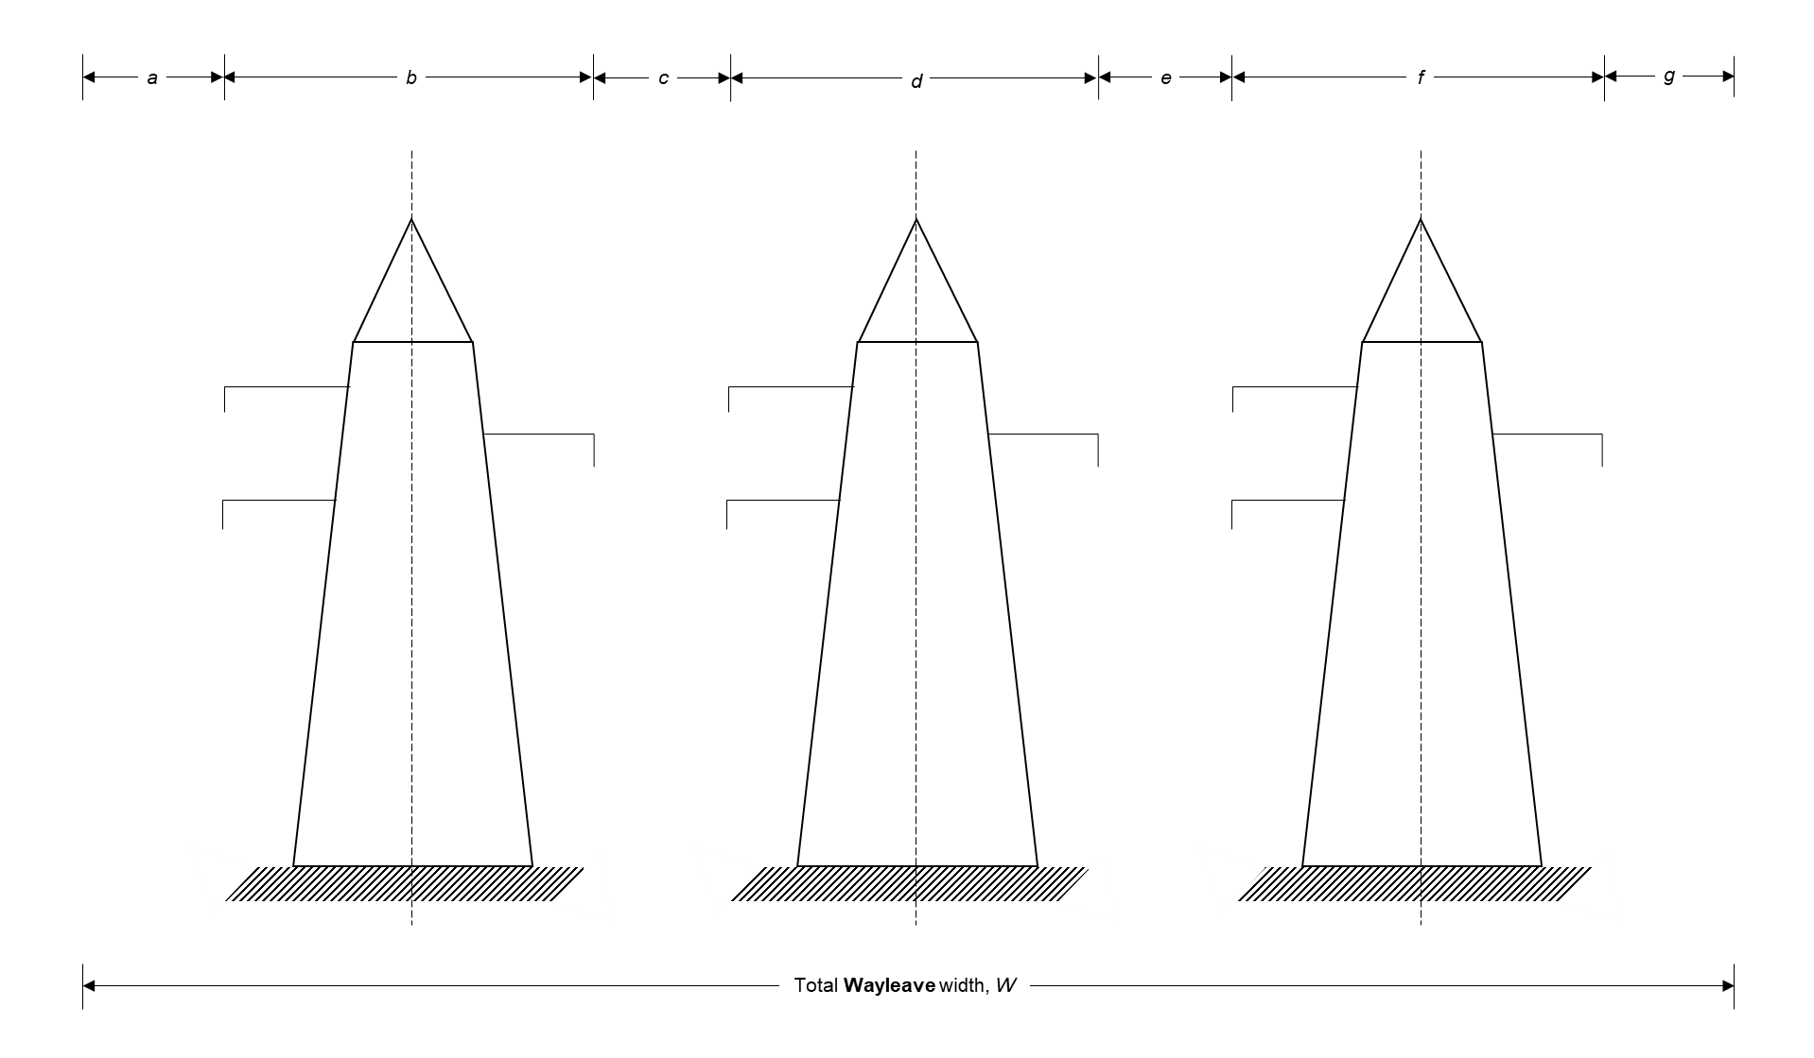
Figure 2.1 66kV to 132kV OHL model
The parameters involved for calculation of Wayleave width for parallel OHL of same Voltage level are:
- ‘W’ which is the recommended minimum Wayleave width;
- ‘a’ which is the maximum recommended distance between the outer conductor and the edge of the Wayleave, and can be obtained from the last column in Table 2.1;
(For OHL configurations as depicted in Figure 2.1, Clearances and dimensions for a and g are the same).
- ‘b’ which is the minimum maintenance Clearance. Maintenance Clearance and conductor Clearance for various Voltage levels are provided in Table 2.3. Conductor Clearance is Clearance between the nearest conductor of an OHL and the tower structure.
(For OHL configurations as depicted in Figure 2.1, Clearances and dimensions for b, d and f are the same).
- ‘c’ which is conductor Clearance plus maintenance Clearance.
(For OHL configurations as depicted in Figure 2.3, clearances and dimensions for c and e are the same).
From Figure 2.1 and the recommended minimum Clearance between conductors of parallel lines as given in Table 2.1 and Table 2.3, the width for Wayleave for three parallel OHL can be determined from the following equation:
 | $$W=a+b+c+d+e+f+g$$ | (1)
But for parallel lines of the same Voltage level, a = g, b = d = f and c = e. Therefore, Equation 1 simplifies to:
 | $$W=2a+3b+2c$$ | (2)
For respective Voltage levels, the recommended minimum values of ‘a’ are given in Table 2.1, the values of ‘b’ are given in Table 2.3 and the values of ‘c’ (conductor Clearance plus maintenance Clearance) are determined from Table 2.3.
- Calculating Wayleave width for 3 x 132kV parallel OHL
For 132 kV OHL, a = 12 m; b = 5.5 m; and c = 8.25 m (i.e., 2.75 m + 5.5 m).
Hence, using Equation 2, the minimum required Wayleave width for three parallel 132 kV OHL would be:
$$W=\left(2*12\right)+\left(3*5.5\right)+\left(2*8.25\right)=57 meters$$
- Calculating Wayleave width for 3 x 88kV parallel OHL
For 88 kV OHL, a = 10 m; b = 5.5 m; and c = 7.5 m (i.e., 2.5 m + 5 m).
Hence, using Equation 2, the minimum required Wayleave width for three parallel 88 kV OHL would be:
$$W=\left(2*10\right)+\left(3*5.5\right)+\left(2*7.5\right)=51.5 meters$$
- Calculating Wayleave width for 3 x 66kV parallel OHL
For 66 kV OHL, a = 10 m; b = 5 m; and c = 7.5 m (i.e., 2.5 m + 5 m).
Hence, using Equation 2, the minimum required Wayleave width for three parallel 66 kV OHL would be:
$$W=\left(2*10\right)+\left(3*5\right)+\left(2*7.5\right)=50 meters$$
- Calculating Wayleave width for 3 x 33kV parallel OHL (Horizontal arrangement)
For 33 kV OHL, a = 5 m; b = 4 m; and c = 6.5 m (i.e., 2.5 m + 4 m).
Hence, using Equation 2, the minimum required Wayleave width for three parallel 33 kV OHL would be:
$$W=\left(2*5\right)+\left(3*4\right)+\left(2*6.5\right)=35 meters$$
- Calculating Wayleave width for 3 x 11kV parallel OHL
For 11 kV OHL, a = 4 m; b = 3.5 m; and c = 5.5 m (i.e., 2 m + 3.5 m).
Hence, using Equation 2, the minimum required Wayleave width for three parallel 11 kV OHL would be:
$$W=\left(2*4\right)+\left(3*3.5\right)+\left(2*5.5\right)=29.5 meters$$
      - Sample calculation of Wayleave for parallel OHL of the same Voltage level (for OHL above 132kV)
The 220kv to 330kV OHL model in Figure 2.2 below should be referred to for calculation of Wayleave widths in this subsection 2.1.3.2.

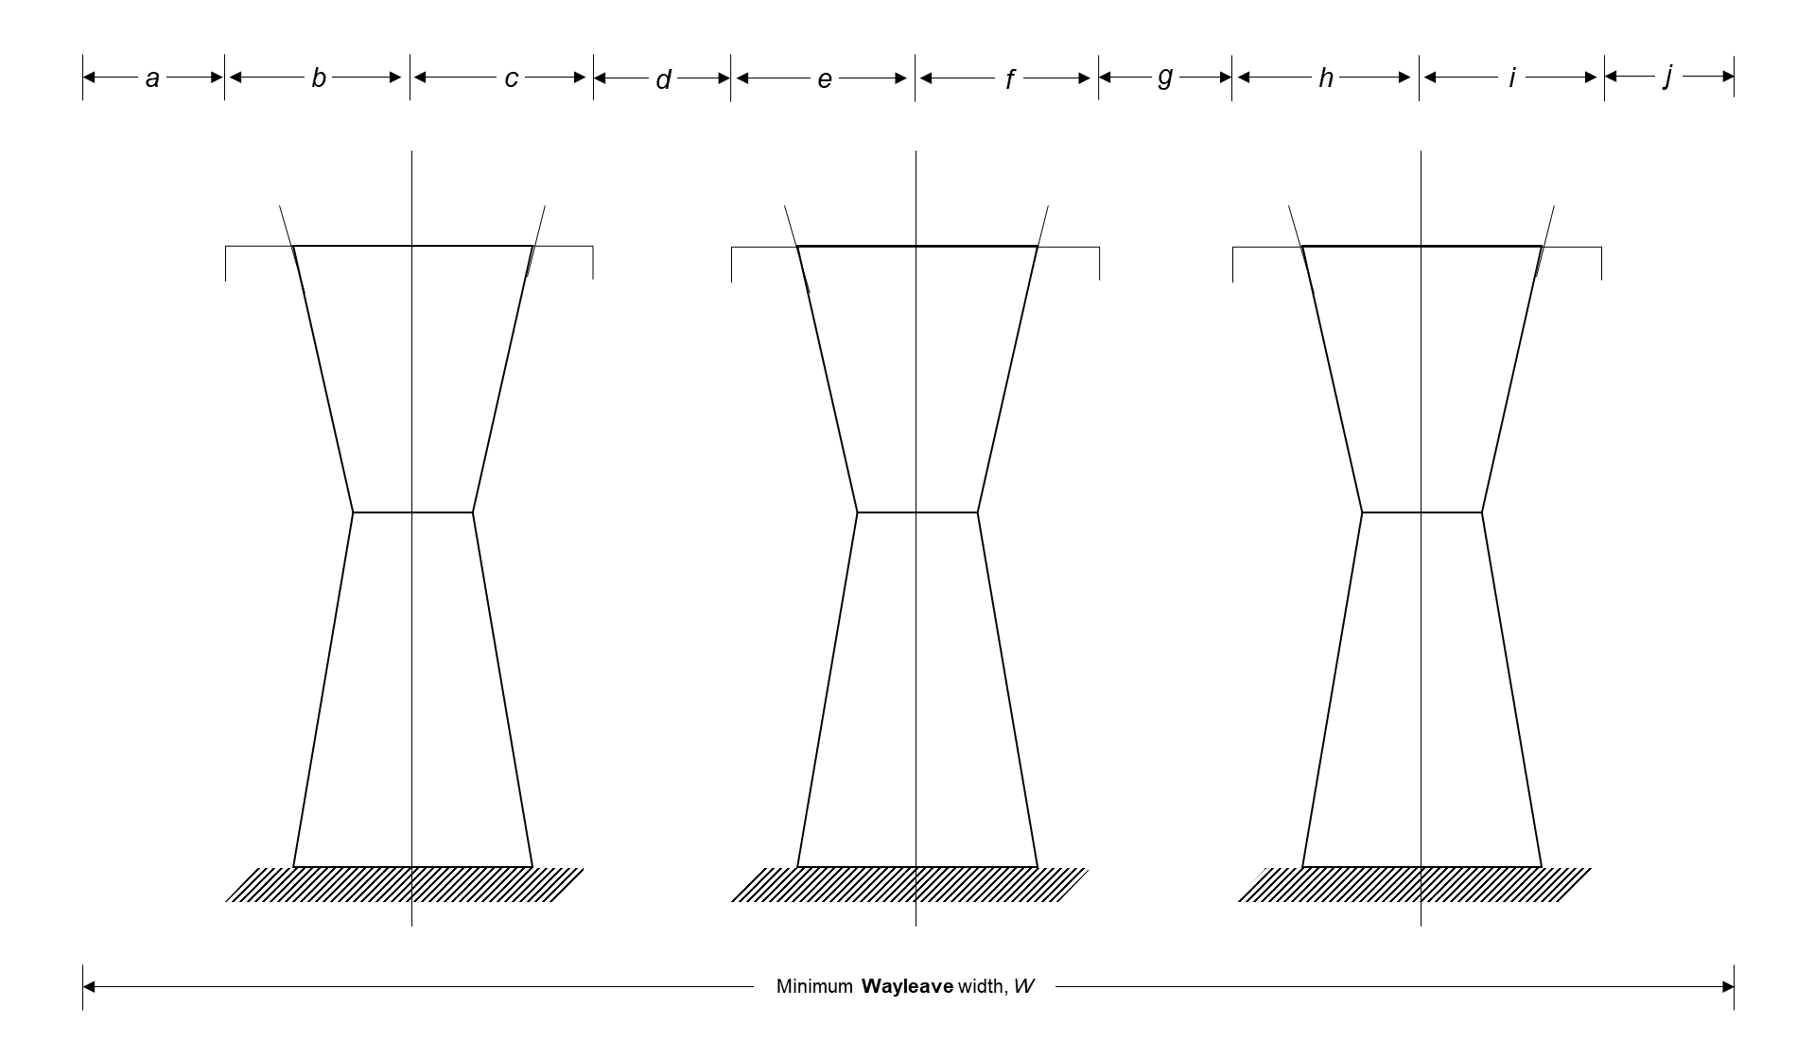
Figure 2.2: 220kV to 330kV OHL model
The parameters involved for calculation of Wayleave width for parallel OHL of same Voltage level (above 132 kV) are:
- ‘W’ which is the recommended minimum Wayleave width;
- ‘a’ which is the maximum recommended distance between the outer conductor and the edge of the Wayleave, and can be obtained from the last column in Table 2.1
(For OHL configurations as depicted in Figure 2.4, clearances and dimensions for a and j are the same).
- ‘b’ which is the minimum maintenance Clearance. Maintenance Clearance and conductor Clearance for various Voltage levels are provided in Table 2.3. Conductor Clearance is Clearance between the nearest conductor of an OHL and the tower structure or ground.
(For OHL configurations as depicted in Figure 2.4, Clearances and dimensions for b, d, e, f, h and i are the same).
- ‘c’ which is conductor Clearance plus maintenance Clearance.
(For OHL configurations as depicted in Figure 2.4, Clearances and dimensions for c and g are the same).
From Figure 2.3 and the recommended minimum Clearance between conductors of parallel lines as given in tables Table 2.1 and Table 2.3, the width for Wayleave for three parallel OHL above 132 kV can be determined from the following equation:
 | $$W=a+b+d+c+e+f+g+i+j$$ | (3)
But for parallel lines of the same Voltage level, a = j, b = d = e = f =h = i and c = g. Therefore, Equation 1 simplifies to:
 | $$W=2a+6b+2c$$ | (4)
For respective Voltage levels, the recommended minimum values of ‘a’ are given in Table 2.1, the values of ‘b’ are given in Table 2.3 and the values of ‘c’ (conductor Clearance plus maintenance Clearance) can be determined from Table 2.3.
- Calculating Wayleave width for 3 x 330kV parallel OHL
For 330 kV OHL, a = 15 m; b = 7.8 m; and c = 13 m (i.e., 5.2 m + 7.8 m).
Hence, using Equation 4, the minimum required Wayleave width for three parallel 330 kV OHL would be:
$$W=\left(2*15\right)+\left(6*7.8\right)+\left(2*13\right)=102.8 meters$$
- Calculating Wayleave width for 3 x 220kV parallel OHL
For 88 kV OHL, a = 15 m; b = 7.45 m; and c = 12 m (i.e., 2.5 m + 5 m).
Hence, using Equation 4, the minimum required Wayleave width for three parallel 220 kV OHL would be:
$$W=\left(2*10\right)+\left(3*5.5\right)+\left(2*7.5\right)=98.7 meters$$
      - Sample calculation of Wayleave for parallel OHL of mixed Voltage level
One 220kV OHL and one 66kV OHL.
For 66kV OHL, a = 10 m, b = 5 m and c = 7.5 m.
For 220kV OHL, a = 15 m, b = 7 m and d = 12 m.
Between two lines the centre distance is 32 m.
Therefore, W = (a + b) for 66kV + (b + d + i) for 220kV
W = 10 + 5 + 12 + 7 + 15 = 49 meters.
  - Minimum Wayleave in recognized Forestry Areas
Where an OHL is routed or planned to be constructed in accordance with Section 23 of the Electricity Act, 2019 through a recognized Forestry Area, the distance at which a single tree or row of trees may grow in the neighborhood of OHL shall be determined taking into account the height of the trees, the extent of foliage and the manner in which the trees grow. The derived Clearance shall be such that it precludes any danger to the OHL. Notwithstanding the aforesaid, the minimum Clearance for an OHL in a recognized Forestry area shall be as provided in Table 2.5.
Table 2.5 Wayleaves for OHL in recognized Forestry areas
OHL Voltage level | Tree restriction distance  on each side of the OHL  center line, in meters | Total Wayleave width, in meters
11kV | 25 m | 50 m
33kV | 25 m | 50 m
66kV | 33 m | 66 m
88kV | 33.5 m | 67 m
132kV | 36 m | 72 m
220kV | 38 m | 76 m
330kV | 39 m | 78 m

MINIMUM CLEARANCE FROM OHL NEAR STRUCTURES
  - Reference Notes of Section 3
    - Safety Clearance from an OHL is a convoluted, site-specific, three-dimensional requirement that may not be resolutely fixed, specified or illustrated in a single Code, Standard, Rule or Regulation – the ultimate required permanent safety Clearance may vary depending on the nature of the object to which the Clearance is being checked.
    - In view of 3.1.1, a Planning Authority or an electricity Licensee may determine their own specific minimum Clearances to OHL.
    - In view of 3.1.1 and 3.1.2, a Developer must, before proceeding with their design and installation or construction, contact both the Planning Authority and a Licensee in the area so that the Planning Authority and Licensee can evaluate the specific location, and determine and specify the required minimum Clearance from existing, or planned, OHL. If such determined and specified minimum Clearance is more than the Clearance specified in this Code, then, the minimum Clearance specified by such Planning Authority or Licensee shall be applicable.
    - If, however, the Planning Authority or electricity Licensee is unable to specify its required minimum Clearance within 10 working days after being contacted, or if the minimum Clearance so specified is less than the minimum safety Clearance specified in this Code, then, the minimum Clearance specified in this Code shall be applicable.
    - A Developer shall not construct or install any structure or equipment in a Wayleave without prior written approval and specification of required Clearances, from the Licensee who owns the Wayleave.
    - Neutral conductors for 0-33kV OHL that are effectively earthed to ground throughout their length may have the same Clearances as guys (see subsection 3.29). Otherwise, the neutral conductors shall have the same Clearances as the phase conductors of the circuit which they are associated with
    - The Clearances from OHL specified in this Section shall apply to external live parts of associated equipment of a Licensee’s OHL such as OHL fuses, exposed live or protection parts of a ground- or pole-mounted transformer and exposed live parts of auto-recloser.
  - Vertical Clearance above ground
    - The minimum vertical Clearance above ground shall be:
- 5.1 m to the lowest phase conduct, for 0 to 11kV OHL, bare type (in open-country)
- 5.0 m to the lowest phase conduct, for 0 to 11kV OHL, insulated type (in open-country)
- 5.3 m to the lowest phase conductor, for 33kV OHL, bare or insulated type (in open-country)
- 5.5 m to the lowest phase conductor, for 0 to 33kV OHL, bare type or insulated type (in other areas)
- 5.9 m to the lowest phase conductor, for 66kV OHL
- 6.3 m to the lowest phase conductor, for 88kV OHL
- 6.7 m to the lowest phase conductor, for 132kV to 220kV OHL
- 7.2 m to the lowest phase conductor, for 330kV OHL.
  - Vertical Clearance above buildings and structures classified as buildings

    - The minimum vertical Clearance above building, structure classified as building, or accessible elevated part of building (and illustrated by letters A and B in figure 3.1 below), shall be:
- 3.7 m to the closest phase conductor, for 0 to 11kV OHL, bare or insulated type
- 5.0 m to the closest phase conductor, for 33kV OHL, bare or insulated type
- 5.3 m to the closest phase conductor, for 66kV OHL
- 5.6 m to the closest phase conductor, for 88kV OHL
- 6.0 m to the closest phase conductor, for 132kV OHL
- 6.9 m to the closest phase conductor, for 220kV OHL
- 8.0 m to the closest phase conductor, for 330kV OHL
NOTE on clause 3.3:
- This clause excludes buildings for explosives magazine. Clearances for those are specified in clauses 3.24.
  - Lateral Clearance near buildings and structures classified as buildings

The minimum Lateral Clearance to walls, projections or inaccessible areas, of buildings or infrastructure classified as buildings (and illustrated by letter C in figure 3.1), shall be:
- 1.7 m to the closest phase conductor, for 0 to 1kV OHL, bare type
- 1.5 m to the closest phase conductor, for 0 to 1kV OHL, insulated type
- 2.3 m to the closest phase conductor, for OHL above 1kV, up to and including 33kV, bare or insulated type
- 2.6 m to the closet phase conductor, for 66kV OHL
- 2.9 m to the closet phase conductor, for 88kV OHL
- 3.3 m to the closet phase conductor, for 132kV OHL
- 4.2 m to the closet phase conductor, for 220kV OHL
- 5.3 m to the closet phase conductor, for 330kV OHL
NOTE on clause 3.4:
- This clause excludes buildings for explosives magazine. Clearances for these are specified in clauses 3.24, respectively.
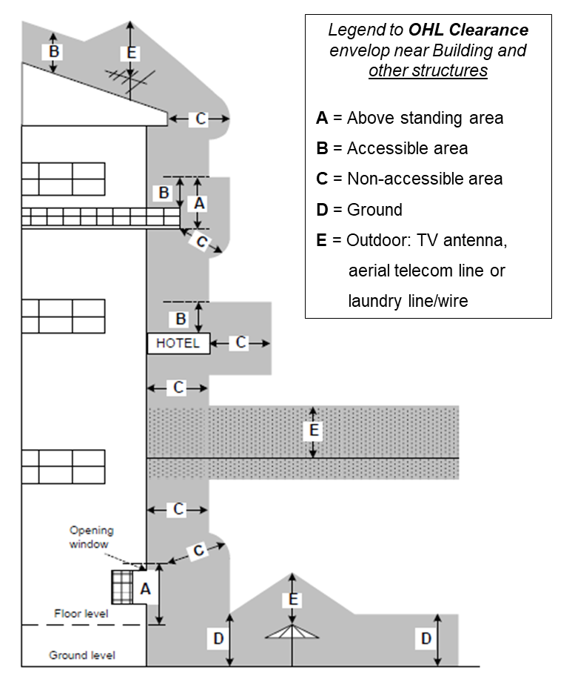
Figure 3.1 Minimum safety Clearance envelop near structures
(Adapted from: Endeavour Energy (2011))
  - Vertical Clearance above structures not classified as buildings
    - The minimum safety Clearance above infrastructure and installations not classified as building or bridge, such as sign posts, billboards, chimneys, laundry wire, TV/radio antenna, tanks for non-flammable substances, fence, gate or gate-traversing path, and upon which personnel may walk on top during maintenance of or other operations on such infrastructure or installation, shall be:
- 3.5 m to the closest phase conductor, for 0 to 1kV OHL, bare type
- 3.4 m to the closest phase conductor, for 0 to 1kV OHL, insulated type
- 4.1 m to the closest phase conductor, for OHL above 1kV, up to and including 33kV, bare or insulated type
- 4.4 m to the closet phase conductor, for 66kV OHL
- 4.7 m to the closet phase conductor, for 88kV OHL
- 5.1 m to the closet phase conductor, for 132kV OHL
- 6.0 m to the closet phase conductor, for 220kV OHL
- 7.1 m to the closet phase conductor, for 330kV OHL
    - The minimum safety Clearance above infrastructure or installation not classified as building or bridge, such as sign posts, billboards, chimneys, laundry wire, TV/radio antenna and tanks for non-flammable substances, fence, gate or gate-traversing path, and on which personnel will not walk on top during maintenance of or other operations on such infrastructure or installation, shall be:
- 1.8 m to the closest phase conductor, for 0 to 1kV OHL, bare type
- 1.1 m to the closest phase conductor, for 0 to 1kV OHL, insulated type
- 2.5 m to the closest phase conductor, for OHL above 1kV, up to and including 33kV, bare or insulated type
- 2.8 m to the closet phase conductor, for 66kV OHL
- 3.0 m to the closet phase conductor, for 88kV OHL
- 3.4 m to the closet phase conductor, for 132kV OHL
- 4.3 m to the closet phase conductor, for 220kV OHL
- 5.4 m to the closet phase conductor, for 330kV OHL
  - Lateral Clearance near structures not classified as buildings
    - The minimum Lateral Clearance near infrastructure or installation not classified as building or bridge, such as sign posts, billboards, chimneys, laundry wire, TV/radio antenna, tanks for non-flammable substances, fence or gate, regardless of whether the portion under consideration is readily accessible to persons or not readily accessible, shall be:
- 1.7 m to the closest phase conductor, for 0 to 1kV OHL, bare type
- 1.5 m to the closest phase conductor, for 0 to 1kV OHL, insulated type
- 2.0 m to the closest phase conductor, for OHL above 1kV, up to and including 33kV, bare or insulated type
- 2.3 m to the closet phase conductor, for 66kV OHL
- 2.6 m to the closet phase conductor, for 88kV OHL
- 3.0 m to the closet phase conductor, for 132kV OHL
- 3.9 m to the closet phase conductor, for 220kV OHL
- 5.0 m to the closet phase conductor, for 330kV OHL
  - Vertical Clearance above bridges
    - The minimum permanent safety Clearance above a bridge shall be:
- 4.7 m from the lowest conductor, for bare type OHL below 11kV
- 4.7 m from the lowest conductor, for 0 to 1kV OHL, insulated type
- 4.8 m from the lowest conductor, for 11kV OHL, bare or insulated type
- 5.0 m from the lowest conductor, for 33kV OHL, bare or insulated type
- 5.3 m from the lowest conductor, for 66kV OHL
- 5.6 m from the lowest conductor, for 88kV OHL
- 6.0 m from the lowest conductor, for 132kV OHL
- 6.6 m from the lowest conductor, for 220kV OHL
- 7.7 m from the lowest conductor, for 330kV OHL
  - Lateral Clearance near bridges
    - The minimum Lateral Clearance beside, under or within readily accessible portions of a bridge including wing, walls and bridge attachments shall be:
- 1.7 m to the closest phase conductor, for 0 to 1kV OHL, bare type
- 2.3 m to the closest phase conductor, for OHL Voltage above 1kV up to and including 33kV, bare or insulated type
- 2.6 m to the closet phase conductor, for 66kV OHL
- 2.9 m to the closet phase conductor, for 88kV OHL
- 3.1 m to the closet phase conductor, for 132kV OHL
- 4.0 m to the closet phase conductor, for 220kV OHL
- 5.1 m to the closet phase conductor, for 330kV OHL
    - The minimum Lateral Clearance beside, under or within ordinarily inaccessible portions of a bridge including wing, walls and bridge attachments shall be:
- 1.4 m to the closest phase conductor, for 0 to 1kV OHL, bare type
- 2.0 m to the closest phase conductor, for OHL Voltage above 1kV up to and including 33kV, bare or insulated type
- 2.3 m to the closet phase conductor, for 66kV OHL
- 2.6 m to the closet phase conductor, for 88kV OHL
- 3.0 m to the closet phase conductor, for 132kV OHL
- 3.9 m to the closet phase conductor, for 220kV OHL
- 5.0 m to the closet phase conductor, for 330kV OHL
NOTE on clause 3.8:
- Lateral Clearances in clause 3.8 shall apply to overpasses
  - Vertical Clearance of OHL crossing above roads, alleys and parking lots
    - The minimum permanent safety Clearance above center-line of national highway, overpass, freeways and routes designated for abnormal loads shall be:
- 6.5 m from the lowest conductor, for 0 to 33kV OHL, bare type (for national highway)
- 5.5 m from the lowest conductor for 0 to 33kV OHL, insulated type (for national highway)
- 7.5 m from the lowest conductor, for 0 to 33kV OHL, bare or insulated type (for freeways and routes designated for abnormal loads)
- 7.5 m from the lowest conductor for 66 to 132kV OHL
- 8.4 m from the lowest conductor for 220kV OHL
- 9.5 m from the lowest conductor for 330kV OHL
    - The minimum permanent safety Clearance above center line of township roads, proclaimed roads and alleys, and parking lots, including above-storey park lots shall be:
- 6.2 m from the lowest conductor, for bare type OHL below 11kV
- 6.3 m from the lowest conductor, for 11kV OHL, bare type
- 6.5 m from the lowest conductor, for 33kV OHL, bare type
- 5.5 m from the lowest conductor, for 0 to 33kV OHL, insulated type
- 6.9 m from the lowest conductor, for 66kV OHL
- 7.1 m from the lowest conductor, for 88kV OHL
- 7.5 m from the lowest conductor, for 132kV OHL
- 7.9 m from the lowest conductor, for 220kV OHL
- 8.8 m from the lowest conductor, for 330kV OHL
    - The minimum permanent safety Clearance specified in clause 3.9.2 shall also be applicable to land such as commercial yard used by trucks, and other private land traversed by trucks, such as cultivated, grazing, forest or orchard land.
    - The minimum permanent safety Clearance above center line of private property driveway not trafficable by trucks or not trafficable by high volume of public vehicles shall be:
- 4.0 m from the lowest conductor, for 0 to 33kV OHL, bare type
- 3.0 m from the lowest conductor, for 0 to 33kV OHL, insulated type
- 5.9 m from the lowest conductor, for 66kV OHL
- 6.3 m from the lowest conductor, for 88kV OHL
- 6.7 m from the lowest conductor, for 132kV to 220kV OHL
- 7.2 m from the lowest conductor, for 330kV OHL
    - The minimum permanent safety Clearance above spaces subject to pedestrians and cyclists only, such as footpath and footbridge, shall be:
- 3.6 m to the closest phase conductor, for 0 to 1kV OHL, bare or insulated type
- 4.4 m to the closest phase conductor, for OHL Voltage above 1kV up to and including 33kV, bare or insulated type
- 4.7 m to the closet phase conductor, for 66kV OHL
- 5.0 m to the closet phase conductor, for 88kV OHL
- 5.4 m to the closet phase conductor, for 132kV OHL
- 6.3 m to the closet phase conductor, for 220kV OHL
- 7.4 m to the closet phase conductor, for 330kV OHL
NOTE on clause 3.9:
- All OHL crossing shall be made at an angle of between 90 degrees (maximum) and 45 degrees (minimum)
- Apart from where crossing, no portion of an OHL shall overhang along actual road or alley
- Where OHL conductors run along and within the limits of road wayleave but do not overhang the roadway, the Clearances of such OHL conductors shall be the same as the respective Clearances specified in the respective sub-clauses.
  - Vertical Clearance above rail track or railway
    - Inside rail stations, the minimum permanent vertical safety Clearance above Broad Gauge railway track shall be:
- 8.1 m from the lowest conductor, for 0 to 33kV OHL, bare type
- 7.5 m from the lowest conductor, for 0 to 33kV OHL, insulated type
- 10.3 m from the lowest conductor, for 66 to 88kV OHL
- 10.9 m from the lowest conductor, for 132kV OHL
- 11.2 m from the lowest conductor, for 220kV OHL
- 12.5 m from the lowest conductor, for 330kV OHL
    - Outside rail stations, the minimum permanent vertical safety Clearance above Broad Gauge railway track shall be:
- 7.5 m from the lowest conductor, for 0 to 33kV OHL, bare type
- 7.0 m from the lowest conductor, for 0 to 33kV OHL, insulated type
- 7.9 m from the lowest conductor, for 66 to 88kV OHL
- 8.5 m from the lowest conductor, for 132kV OHL
- 8.8 m from the lowest conductor, for 220kV OHL
- 10.5 m from the lowest conductor, for 330kV OHL
    - Inside rail stations, the minimum permanent vertical safety Clearance above Narrow Gauge railway track shall be:
- 7.2 m from the lowest conductor, for 0 to 33kV OHL, bare type
- 6.7 m from the lowest conductor, for 0 to 33kV OHL, insulated type
- 9.1 m from the lowest conductor, for 66 to 88kV OHL
- 9.8 m from the lowest conductor, for 132kV OHL
- 10.0 m from the lowest conductor, for 220kV OHL
- 12.0 m from the lowest conductor, for 330kV OHL
    - Outside rail stations, the minimum permanent vertical safety Clearance above Narrow Gauge railway track shall be:
- 6.7 m from the lowest conductor, for 0 to 33kV OHL, bare type
- 6.5 m from the lowest conductor, for 0 to 33kV OHL, insulated type
- 6.7 m from the lowest conductor, for 66 to 88kV OHL
- 7.3 m from the lowest conductor, for 132kV OHL
- 7.6 m from the lowest conductor, for 220kV OHL
- 9.0 m from the lowest conductor, for 330kV OHL
NOTE on clause 3.10 and 3.11:
- OHL crossing shall be made at an angle
- Apart from where crossing, no portion of an OHL may overhang along railway
- Where OHL conductors overhang along railway or run along and within the limits of railway track wayleave, the Clearances of such OHL conductors shall be the same as the respective Clearances specified in the sub-clauses
- The minimum Clearances provided in this clause do not apply to electrified railways using overhead trolley conductors as they are currently not available in the Zambia ESI.
  - Lateral Clearances near rail track or railway
    - For railways that handle standard rail cars (rail cars of width around 3.2 meters to 3.3 meters), the Lateral Clearance of OHL to the nearest respective rail shall be equal to the respective required vertical Clearances specified in this clause minus 4.6 meters.
    - For railways that only handle cars smaller than the standard cars, the Lateral Clearance of OHL to the nearest rail may be reduced by one-half the difference between the width of a standard rail car and the width of the narrower car.
  - Vertical and Lateral Clearances near aerial telecommunication line
    - The minimum permanent safety Clearance above or Lateral Clearance near aerial telecommunication line on structures which are NOT jointly shared with electricity OHL shall be:
- 1.4 m to the closest phase conductor, for 0 to 11kV OHL, bare or insulated type
- 1.7 m to the closest phase conductor, for 33kV OHL, bare or insulated type
- 2.5 m to the closest phase conductor, for 66kV to 88kV OHL
- 2.8 m to the closest phase conductor, for 132kV OHL
- 3.1 m to the closest phase conductor, for 220kV OHL
- 4.2 m to the closest phase conductor, for 330kV OHL.
    - The minimum permanent safety Clearance above, or Lateral Clearance near, aerial telecommunication line on structures which are jointly shared with electricity OHL shall be:
- 1.1 m to the closest phase conductor, for 0 to 11kV OHL, bare or insulated type
- 1.3 m to the closest phase conductor, for 33kV OHL, bare or insulated type
- 1.9 m to the closest phase conductor, for 66kV to 88kV OHL
- 2.3 m to the closest phase conductor, for 132kV OHL
- 3.1 m to the closest phase conductor, for 220kV OHL
- 4.2 m to the closest phase conductor, for 330kV OHL.
NOTE on clause 3.12:
- The Clearances specified in this clause apply to bare telecommunication lines. The Clearance for insulated telecommunication line shall be determined by subtracting 0.4 meters from the applicable specified OHL
- OHL, of any Voltage level, owned by a Licensee shall always be routed above aerial telecommunication line
- The neutral conductor shall be considered as having the same Voltage classification as the circuit which it is associated.
  - Vertical Clearance above water level in swimming pool or above walk way around swimming pool, diving platform, tower and water slide or other fixed, pool-related structures
Having swimming pool, or walk way around swimming pool, diving platform, tower and water slide or other fixed, pool-related structures underneath OHL of any Voltage level is Not Permitted, except where such swimming pool and pool-related structures are fully enclosed by a solid or screened permanent structure, in which case the relevant Clearance specified in clauses 3.3 and 3.5 shall apply.
  - Lateral Clearance of OHL near edge of swimming pool, walk way around swimming pool, diving platform, tower or water slide or other fixed, pool-related structures
    - The minimum Lateral Clearance to the edge of swimming pool, or walk way around swimming pool, diving platform, tower and water slide or other fixed, pool-related structures, shall be:
- 7.0 m to the closest phase conductor, for 0 to 1kV OHL, bare type
- 6.9 m to the closest phase conductor, for 0 to 1kV OHL, insulated type
- 7.6 m to the closest phase conductor, for OHL of Voltage above 1kV, up to and including 33kV, bare type
- 7.9 m to the closest phase conductor, for 66kV OHL
- 8.2 m to the closest phase conductor, for 88kV OHL
- 8.6 m to the closest phase conductor, for 132kV OHL
- 9.5 m to the closest phase conductor, for 220kV OHL
- 10.6 m to the closest phase conductor, for 330kV OHL
  - Height for attaching Overhead Service Line to building or structure
    - OHSL shall have a minimum Clearance of 1.0 m in any direction from door, window that is designed to open, porch, fire escape, or similar locations.
    - Connection and termination of an OHSL at a building shall be through an OHSL support mast as illustrated in Figure 3.2 below. The connection and termination shall contain all the components shown in the red circle in Figure 3.2, i.e., mast, service entrance cap, drip-looped OHSL entrance conductors and splicing between OHSL conductors and OHSL entrance conductors
    - No other item shall be attached to or supported by the mast except OHSL.
    - Mast used for the support of OHSL shall be installed in compliance with the following requirements:
- The mast shall be of adequate strength or be supported by braces or guys to withstand safely the strain imposed by the OHSL conductors. Hubs intended for use with a conduit that serves as a OHSL mast shall be identified for use with OHSL-entrance equipment.
- OHSL conductors shall not be attached to an OHSL mast between a service entrance cap or the end of the conduit and a coupling, where the coupling is located above the last point of securement to the building or other structure or is located above the building or other structure.
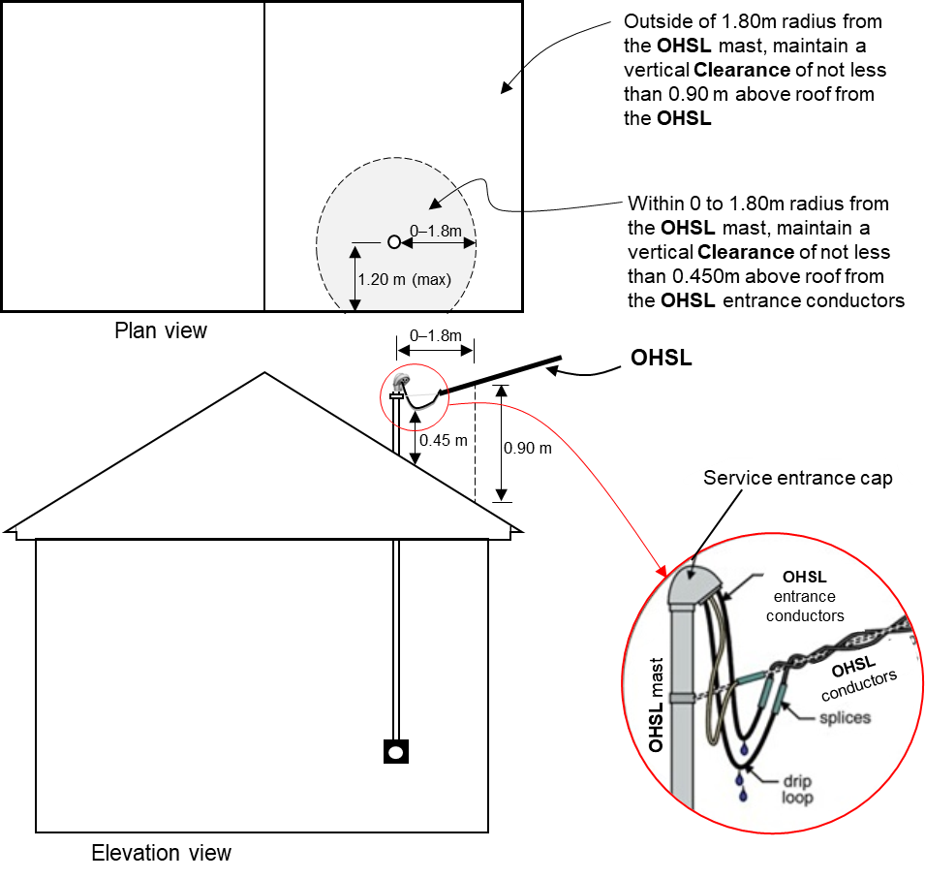
Figure 3.2 Clearance of OHSL terminating on support mast of a building.
NOTE on clause 3.15:
- Attaching OHSL for supply is Not Permitted for the following cases:
- Attaching OHSL to a served building or structure without a support mast;
- Attaching bare OHSL, unless such OHSL is guarded. Within the meaning of this Code, Overhead Service Line is considered guarded if its conductor(s) and any associated neutral are supported on or cabled together with an effectively earthed bare messenger or neutral, or with multiple concentric neutral conductors, where any associated neutral conductor have the same Clearance as the phase conductor of the circuit with which the neutral is associated, and where cables have an effectively earthed continuous metal sheath or shield. In that case, the Clearance for insulated OHSL shall apply.
  - Vertical Clearance above an above-ground or underground infrastructure used for storage or handing of flammable substances
It is Not Permitted to have an above ground or underground infrastructure, or part thereof, used for storage or handling of flammable substances defined as Class 0, Class I or Class III in the Zambian Standard ZS 402:2006, underneath an OHL, except where such a structure is fully enclosed by a solid permanent structure, in which case the Clearances of clause 3.3 shall apply to the enclosing structure.
NOTE on clause 3.16:
- The word infrastructure or installation in sub-clause 3.16 may refer to forecourt, underground or above ground tank or corresponding tank farm, dispenser, loading or off-loading gantry at a fuel depot, vent or oil interceptor
  - Lateral Clearance near underground and above-ground infrastructure used for storage or handling of flammable substances
    - The minimum permanent Lateral Clearance near infrastructure or installation used for storage or handling of flammable substances defined as Class I, Class II or Class III in the Zambian Standard ZS 402:2006, shall be:
- 15 m to the closest phase conductor, for 0 to 33kV OHL, bare or insulated type
- 30 m to the closest phase conductor, for Voltages over 33kV, up to and including 132kV OHL
- 60 m to the closest phase conductor, for Voltages over 132kV, up to and including 330kV OHL
NOTE on sub-clause 3.17.1:
- The word infrastructure or installation in sub-clause 3.17.1 may refer to forecourt, underground or above ground tank or corresponding tank farm, dispenser, loading or off-loading gantry at a fuel depot, vent or oil interceptor.
    - The minimum permanent Lateral Clearance near infrastructure or installation used for storage or handling of flammable substances defined as Class 0 in the Zambian Standard ZS 402:2006, shall be:
- 15 m to the closest phase conductor, for 0 to 33kV OHL, bare or insulated type, for installation whose single or aggregated holding capacity is between 460 liters and 2,273 liters
- 30 m to the closest phase conductor, for Voltage over 33kV, up to and including 132kV OHL, for installation whose single or aggregated holding capacity is over 2,273 liters but below 9,094 liters
- 60 m to the closest phase conductor, for Voltage over 33kV, up to and including 330kV OHL, for installation whose single or aggregated holding capacity is 9,094 liters or more
NOTE on sub-clause 3.17.2:
- The words infrastructure and installation in sub-clause 3.17.2 may refer to depot, tank or cylinder, singularly or as a collection
  - Vertical Clearance above navigable and non-navigable water bodies
    - The minimum permanent vertical Clearance above water areas not suitable for sail-boating or where sail-boating is prohibited, including water area such as dam, pond, reservoir, tidal water, river, stream and canal, shall be:
- 4.6 m to the closest phase conductor, for 0 to 1kV OHL, bare type
- 4.4 m to the closest phase conductor, for 0 to 1kV OHL, insulated type
- 5.2 m to the closest phase conductor, for over 1kV to 11kV OHL, bare or insulated type
- 5.4 m to the closets phase conductor, for 33kV OHL
- 5.8 m to the closest phase conductor, for 66kV OHL
- 6.0 m to the closest phase conductor, for 88kV OHL
- 6.4 m to the closest phase conductor, for 132kV OHL
- 7.3 m to the closest phase conductor, for 220kV OHL
- 8.4 m to the closest phase conductor, for 330kV OHL.
    - The minimum permanent vertical Clearance above water area suitable for sail-boating, or where sail-boating is not prohibited including water area such as dam, pond, reservoir, tidal water, river, stream and canal, whereby the unobstructed surface area of such water area is less than 0.08 km², shall be:
- 5.6 m to the closest phase conductor, for 0 to 1kV OHL, bare type
- 5.5 m to the closest phase conductor, for 0 to 1kV OHL, insulated type
- 6.2 m to the closest phase conductor, for over 1kV to 11kV OHL, bare or insulated type
- 6.4 m to the closets phase conductor, for 33kV OHL
- 6.8 m to the closest phase conductor, for 66kV OHL
- 6.8 m to the closest phase conductor, for 88kV OHL
- 7.4 m to the closest phase conductor, for 132kV OHL
- 8.3 m to the closest phase conductor, for 220kV OHL
- 9.4 m to the closest phase conductor, for 330kV OHL.
    - The minimum permanent vertical Clearance above water area suitable for sail-boating, or where sail-boating is not prohibited, including water area such as dam, pond, reservoir, tidal water, river, stream and canal, whereby the unobstructed surface area of such water area is more than 0.08 km² but less than or equal to 0.8 km², shall be:
- 8.1 m to the closest phase conductor, for 0 to 1kV OHL, bare type
- 7.9 m to the closest phase conductor, for 0 to 1kV OHL, insulated type
- 8.7 m to the closest phase conductor, for over 1kV to 11kV OHL, bare or insulated type
- 8.9 m to the closets phase conductor, for 33kV OHL
- 9.3 m to the closest phase conductor, for 66kV OHL
- 9.5 m to the closest phase conductor, for 88kV OHL
- 9.9 m to the closest phase conductor, for 132kV OHL
- 10.8 m to the closest phase conductor, for 220kV OHL
- 11.9 m to the closest phase conductor, for 330kV OHL.
    - The minimum permanent vertical Clearance above water area suitable for sail-boating, or where sail-boating is not prohibited, including water area such as dam, pond, reservoir, tidal water, river, stream and canal, whereby the unobstructed surface area of such water area is more than 0.8 km² but less than or equal to 8 km², shall be:
- 9.9 m to the closest phase conductor, for 0 to 1kV OHL, bare type
- 9.8 m to the closest phase conductor, for 0 to 1kV OHL, insulated type
- 10.5 m to the closest phase conductor, for over 1kV to 11kV OHL, bare or insulated type
- 10.7 m to the closets phase conductor, for 33kV OHL
- 11.1 m to the closest phase conductor, for 66kV OHL
- 11.3 m to the closest phase conductor, for 88kV OHL
- 11.7 m to the closest phase conductor, for 132kV OHL
- 12.6 m to the closest phase conductor, for 220kV OHL
- 13.7 m to the closest phase conductor, for 330kV OHL.
    - The minimum permanent vertical Clearance above water area suitable for sail-boating, or where sail-boating is not prohibited, including water area such as dam, pond, reservoir, tidal water, river, stream and canal, whereby the unobstructed surface area of such water area is more than 8 km², shall be:
- 11.7 m to the closest phase conductor, for 0 to 1kV OHL, bare type
- 11.6 m to the closest phase conductor, for 0 to 1kV OHL, insulated type
- 12.3 m to the closest phase conductor, for over 1kV to 11kV OHL, bare or insulated type
- 12.5 m to the closets phase conductor, for 33kV OHL
- 12.9 m to the closest phase conductor, for 66kV OHL
- 13.1 m to the closest phase conductor, for 88kV OHL
- 13.5 m to the closest phase conductor, for 132kV OHL
- 14.0 m to the closest phase conductor, for 220kV OHL
- 15.1 m to the closest phase conductor, for 330kV OHL.
    - The minimum permanent vertical Clearance above water level at site for established boat ramp or associated rigging area, or area posted with sign for rigging or launching sail boats, shall have a Clearance of 1.5 m greater than Clearance specified in sub-clauses 3.18.2 to 3.18.5, for the type of water area served by the launching site.
NOTE on clause 3.18:
- For natural water areas such as lakes, rivers, canals and streams, the specified Clearances are with reference to the normal rain-season water level of the water area. For the dam, the specified Clearance is with respect to the spillway level
- Care shall be taken not to place support structures of OHL in the 50 to 100-year flood plains
- The Clearance over river, stream or canal shall be based on the largest surface area of any 1.6 km-long segment that includes the crossing.
- The Clearance over river, stream or canal normally used to provide access for sailboats to a larger body of water shall be the same as that required for the larger body of water.
- Where the Zambia Army Corps of Engineers or surrogate thereof, or the State, has issued a crossing permit, Clearances of the permit shall govern.
  - Clearance between conductors of different OHL circuit on the same support structure
    - The following minimum permanent Clearance shall be maintained between closest conductors of different OHL circuit on the same support:
- 1.0 m, if the higher Voltage of either circuit is less than 33kV and the lower Voltage of either circuit is less than or equal to 1kV
- 1.2 m, if the higher Voltage of either circuit is less than 33kV and lower Voltage of either circuit is greater than 1kV
- 1.5 m, if the higher Voltage of either circuit is greater than or equal to 33kV to 132kV and the lower Voltage of either circuit is less than or equal to 1kV
- 2.0 m, if the higher Voltage of either circuit is greater than or equal to 33kV to 132kV and the lower Voltage of either circuit is greater than 1kV
- 2.5 m, if the higher Voltage of either circuit is greater than 132kV and the lower Voltage of either circuit is less than or equal to 132kV.
NOTE on clause 3.19:
- Conductors of higher Voltage OHL shall always be installed above conductors of lower Voltage OHL
- The Clearance specified are for
  - Lateral Clearance between conductors of different OHL circuit on different support structures
The arrangement of Lateral Clearances specified in this section is illustrated in Figure 3.3 below.
    - The following minimum Lateral Clearance shall be maintained between closest conductors of different OHL circuit on different supports:
- 0.6 m, if the higher Voltage of either circuit is less than 1kV, and if either of the circuits has insulated type OHL
- 1.0 m, if the higher Voltage of either circuit is less than 1kV, and if both of the circuits have bare OHL conductors
- 1.2 m, if the higher Voltage of either circuit is greater than or equal to 1kV, to 33kV
- 1.8 m, if the higher Voltage of either circuit is greater than 33kV, to 66kV
- 2.4 m, if the higher Voltage of either circuit is greater than 66kV, to 132kV
- 2.8 m, if the higher Voltage of either circuit is greater than 132kV, to 220kV
- 3.9 m, if the higher Voltage of either circuit is greater than 220kV, to 330kV
NOTE on clause 3.20:
- Conductors of higher Voltage OHL shall always be installed above conductors of lower Voltage OHL
  - Vertical Clearance between conductors of different OHL circuit on different support structure
The arrangement of vertical Clearances specified in this section is illustrated in Figure 3.3 below.
    - The minimum vertical Clearance for effectively earthed guy-wire, span-wire, messenger, neutral conductor effectively earthed throughout its length, or overhead shield/surge-protection wires for OHL shall be:
- 0.6 m from the lowest conductor, for 0 to 33kV OHL
- 1.0 m from the lowest conductor, for 66kV OHL
- 1.2 m from the lowest conductor, for 88kV OHL
- 1.6 m from the lowest conductor, for 132kV OHL
- 2.5 m from the lowest conductor, for 220kV OHL
- 3.6 m from the lowest conductor, for 330kV OHL
    - The minimum vertical Clearance for highest conductor of 0 to 33kV OHL shall be:
- 0.6 m from the lowest conductor of the other OHL circuit of Voltage 0 to 33kV
- 1.0 m from the lowest conductor of the other OHL circuit of Voltage 66kV
- 1.2 m from the lowest conductor of the other OHL circuit of Voltage 88kV
- 1.6 m from the lowest conductor of the other OHL circuit of Voltage 132kV
- 2.5 m from the lowest conductor of the other OHL circuit of Voltage 220kV
- 3.6 m from the lowest conductor of the other OHL circuit of Voltage 330kV
    - The minimum vertical Clearance for highest conductor of 66kV OHL shall be:
- 1.3 m from the lowest conductor of the other OHL circuit of Voltage 66kV
- 1.5 m from the lowest conductor of the other OHL circuit of Voltage 88kV
- 2.0 m from the lowest conductor of the other OHL circuit of Voltage 132kV
- 2.9 m from the lowest conductor of the other OHL circuit of Voltage 220kV
- 4.0 m from the lowest conductor of the other OHL circuit of Voltage 330kV
    - The minimum vertical Clearance for highest conductor of 88kV OHL shall be:
- 1.7 m from the lowest conductor of the other OHL circuit of Voltage 88kV
- 2.2 m from the lowest conductor of the other OHL circuit of Voltage 132kV
- 3.1 m from the lowest conductor of the other OHL circuit of Voltage 220kV
- 4.1 m from the lowest conductor of the other OHL circuit of Voltage 330kV
    - The minimum vertical Clearance for highest conductor of 132kV OHL shall be:
- 2.6 m from the lowest conductor of the other OHL circuit of Voltage 132kV
- 3.5 m from the lowest conductor of the other OHL circuit of Voltage 220kV
- 4.6 m from the lowest conductor of the other OHL circuit of Voltage 330kV
    - The minimum vertical Clearance for highest conductor of 220kV OHL shall be:
- 4.4 m from the lowest conductor of the other OHL circuit of Voltage 220kV
- 5.5 m from the lowest conductor of the other OHL circuit of Voltage 330kV
    - The minimum vertical Clearance for highest conductor of 330kV OHL shall be 6.6 m from the lowest conductor of the other OHL circuit of Voltage 330kV
NOTE on clause 3.21:
- Conductors of higher Voltage OHL shall always be routed above conductors of lower Voltage OHL
- For interpretation of this clause, neutral and earth wires are considered as conductors for the circuit which they are associated.
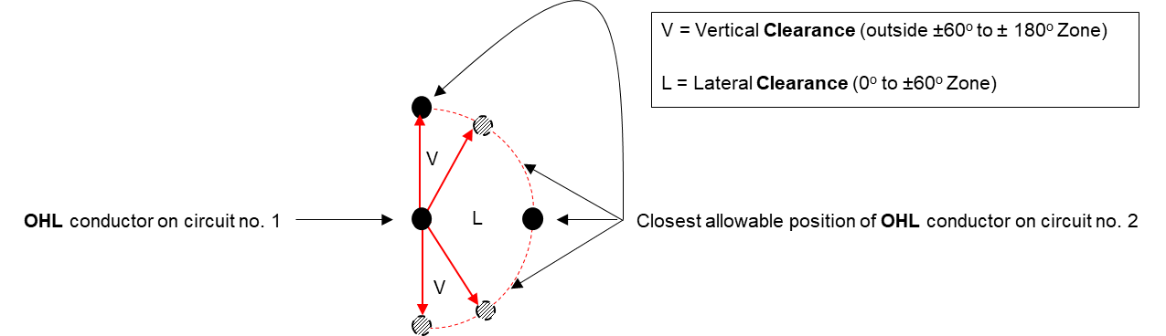
Figure 3.3 Clearance envelop for OHL conductors on different circuits
  - Clearances to OHL in the vicinity of solar PV plant
Development of solar PV farms or plants is a relatively new in Zambia. While, as of 2021, there is limited research and recommendations publicly available even from other jurisdictions world-wide regarding safety Clearances of PV solar plants in the vicinity of OHL, the following shall be observed, in order to achieve the barest minimum safety Clearances:
    - For solar PV panels directly underneath OHL conductors, the highest point on the solar panels shall comply with minimum vertical safety Clearances specified in clause 3.5 of this Code.
    - For Lateral Clearance at the solar PV farm or installation, Clearances specified in clause 3.6 of this Code shall be observed.
NOTE on clause 3.22:
- Sub-clause 3.22.1 implies that the solar PV plant developer shall determine the maximum height of any structure to make sure safety clearance limits are not breached. In this regard, the Licensee owning the OHL and assets concerned must be approached to supply profile drawings which should aid the developer to plan the PV solar farm and determine the maximum height of panels and equipment
- PV solar farm or plant developer should bear in mind that any of their solar PV panels which would be directly underneath OHL risk being damaged in an event that a conductor or fitting falls to the ground. There is also a risk of damage during adverse weather conditions, such as lightning storms, and system faults
- Further, as OHL towers are normally earthed, a weather event such as lightning can cause a rise in the earth potential around the base of a tower. Therefore, solar PV panel support structures and supply cables should be adequately earthed and bonded together to minimise the effects of this temporary rise in earth potential
- Any metallic fencing of a PV solar farm that is located under a OHL will pick up an electrical charge. For this reason, all fencing shall be adequately earthed to minimise micro-shocks to the public
- During normal or routine maintenance or in an emergency, the Licensee owning the OHL may require unrestricted access to their OHL or assets. So, if a tower of a OHL is enclosed in a solar PV farm compound, the Licensee owning the OHL may need full access for their equipment, machinery and vehicles, including access through any compound gates. During maintenance, especially during re-tensioning of conductors, Licensee owning the OHL may need sufficient space near their OHL or towers for winches and cable drums. If sufficient space is not available, the Licensee owning the OHL may require solar panels to be temporarily removed. This may represent a cost to the solar PV plant, which shall be agreed in advance through an Agreement between PV solar plant owner and the Licensee owning the OHL.
  - Clearances to Transmission OHL in the vicinity of wind farms
    - The following two main criteria based on the 2016 research in England shall be applied to siting of wind farms with respect to OHL whose voltage is equal or over 66kV:
- The turbine shall be far away enough to avoid the possibility of toppling onto the OHL;
- The turbine shall be far away enough to avoid damage to the OHL from downward wake effects, also known as turbulence.
NOTE on clause 3.23:
- The toppling distance is the minimum horizontal distance between the worst-case pivot point of the wind turbine and the conductors hanging in still air. It is the greater of:
- The tip height of the turbine plus 10%, OR
- The tip height of the turbine plus the electrical safety Clearance that applies to the OHL.
- To minimise the downward wake effect on an overhead line, the wind turbine shall be three times the rotor distance away from the center of the OHL.
- Wake effects can prematurely age conductors and fittings, significantly reducing the life of the OHL and assets. For that reason, careful consideration should be taken if a wind turbine needs to be sited within the above limits. Agreement between from OHL owner and PV solar farm/plant developer shall be required.
  - Clearance to OHL in the vicinity of explosive magazine and quarry blasting
    - Having an explosive magazine, quarry site or quarry-blasting underneath OHL of any Voltage level is Not Permitted.
    - The Lateral Clearance from OHL to an explosive magazine shall be:
- 15 m to the closest conductor of OHL Voltage below 0.4kV
- 20 m to the closest conductor of OHL Voltage from 0.4kV to 33kV
- 30 m to the closest conductor of OHL Voltage above 33kV
    - The Lateral Clearance from the closest conductor of OHL to quarry blasting site shall be 150 m for 0 to 33kV OHL, and 200 m for OHL Voltage greater than 33kV.
  - Clearance to OHL in the vicinity of fire hydrants located outside buildings
    - Having fire hydrants underneath OHL of any Voltage level is Not Permitted.
    - The minimum Lateral Clearance from the 0 to 330kV OHL or the OHL support structure, whichever shall be closest, to a fire hydrant located outside the building shall be 30 m, but this Clearance may be reduced to 20 m for 0 to 0.4kV supply or OHSL.
  - Clearance to OHL in the vicinity of trees and hedges
    - Having trees underneath OHL of any Voltage level is Not Recommended.
    - The Lateral Clearance from OHL to tree or hedge unable to support a ladder or being climbed, shall be:
- 0.8 m to the closest conductor or bare live metal work of OHL Voltage below 33kV
- 1.1 m to the closest conductor or bare live metal work of 33kV to 66kV OHL
- 1.4 m to the closest conductor or bare live metal work of 88kV OHL
- 1.8 m to the closest conductor or bare live metal work of 132kV OHL
- 2.7 m to the closest conductor or bare live metal work of 220kV OHL
- 3.8 m to the closest conductor or bare live metal work of 330kV OHL
    - The Lateral Clearance from OHL to tree or hedge capable of supporting a ladder or being climbed, shall be:
- 3.0 m to the closest conductor or bare live metal work of OHL Voltage below 33kV
- 3.2 m to the closest conductor or bare live metal work of 33kV to 66kV OHL
- 3.4 m to the closest conductor or bare live metal work of 88kV OHL
- 3.9 m to the closest conductor or bare live metal work of 132kV OHL
- 4.8 m to the closest conductor or bare live metal work of 220kV OHL
- 5.9 m to the closest conductor or bare live metal work of 330kV OHL
    - The Lateral Clearance from OHL to trees in an orchard shall be:
- 3.0 m to the closest conductor or bare live metal work of OHL Voltage below 33kV
- 3.2 m to the closest conductor or bare live metal work of 33kV to 66kV OHL
- 3.4 m to the closest conductor or bare live metal work of 88kV OHL
- 3.9 m to the closest conductor or bare live metal work of 132kV OHL
- 4.8 m to the closest conductor or bare live metal work of 220kV OHL
- 5.9 m to the closest conductor or bare live metal work of 330kV OHL
  - Clearance to OHL in the vicinity of street lighting
    - The Clearance from closest conductor of OHL of Voltage 0 to 0.4kV to a lantern on the same pole shall be 1.0 m.
    - The Clearance from lowest insulated conductor of 0 to 0.4kV OHL to a lantern on a different pole shall be 1.0 m.
    - The Clearance from lowest insulated conductor of 0 to 0.4kV OHL to a column of street lighting on a different pole shall be 0.3 m.
    - The Clearance from lowest bare conductor of 0 to 0.4kV OHL to a lantern or column of street lighting on a different pole shall be 1.5 m.
    - The Lateral Clearance from closest conductor of part of support structure of OHL to a lantern or column of street lighting, with column in normal upright position or column bending in the direction of the OHL, shall be:
- 1.5 m for 0 to 0.4kV OHL
- 1.7 m for 11 to 33kV OHL
- 2.0 m for 66kV OHL
- 2.3 m for 88kV OHL
- 2.7 m for 2.3 m for 132kV OHL
- 3.6 m for 2.3 m for 220kV OHL
- 4.7 m for 330kV OHL.
  - Clearance from OHL to other objects and spaces (general)
    - The minimum Lateral Clearance from the closest conductor of an OHL to irrigation pipe, slurry gun or high pressure hose shall be 30.0 m for any Voltage level up to 330kV
    - The minimum Lateral Clearance from the closest conductor of an OHL to a playing field shall be 8.5 m for any Voltage level up to 330kV
    - The minimum Lateral Clearance from the closest conductor of an OHL to caravan site shall be 9.0 m for any Voltage level up to 330kV
    - The minimum Lateral Clearance from the closest conductor of an OHL to a water well or a water borehole site shall be 15.0 m for any Voltage level up to 330kV. It is Not Permitted to have a water well or a site of a water borehole underneath any OHL
    - The Safe Approach Distance to OHL or its exposed live parts, for persons, shall be:
- 0.5 m for OHL less than 1kV
- 1.5 m for 1kV to 11kV OHL
- 2.5 m for 33kV OHL
- 3.0 m for 66kV OHL
- 3.2 m for 88kV OHL
- 4.2 m for 132kV OHL
- 6.0 m for OHL over 132kV
  - Clearance from OHL support structure to other objects
Supporting structures, support arms, anchor guys, and equipment attached thereto, and braces shall have the Clearances from other objects as specified in this subsection 3.29. The Clearance shall be measured between the nearest parts of the objects concerned.
    - The minimum Clearance from fire hydrants shall 1.2 m. This Clearance may be reduced by prior written agreement between the owner of the associated OHL and the fire authority.
    - For streets, roads, and highways where there are kerbs, the OHL support structure shall be located at sufficient distance from the kerb to avoid contact by non-abnormal load vehicles using the roadway. For re-directional kerb, the minimum Lateral Clearance behind the kerb shall be 0.150 m from the OHL support structure.
    - For streets, roads, and highways where there no are kerbs, the OHL support structure shall be located at sufficient distance from the roadway to avoid contact by non-abnormal load vehicles using the roadway.
    - Locating OHL installations on streets, roads, or highways that have narrow wayleave or closely abutting improvements shall be considered as a special case which shall be resolved through prior written agreement between Licensee proposing or owning OHL and an authority of Government exercising jurisdiction over location of the structure, in a manner consistent with the prevailing conditions and limitations.
    - Where an authority of Government exercising jurisdiction over the location structure has issued a permit, or otherwise approved, specific locations for OHL supporting structures, the issued permit or approval shall govern.
    - Where railway tracks are parallel to or crossed by OHL, all portions of supporting structures, support arms, anchor guys, and equipment attached thereto less than 6.7 m above the nearest track rail, the minimum Clearance shall be 3.6 m from the nearest track rail, except where necessary to provide safe operating conditions that require an uninterruptible view of signals and signs along tracks, in which case the Licensee proposing or owning the OHL, and the railway track owner shall agree on where to locate the OHL support structures in order to achieve the necessary Clearance or reduce the Clearance.

MINIMUM CLEARANCES WHEN WORKING NEAR OHL
  - General Notes to Section 4
    - This section of the Code specifies minimum safety Clearances which must be observed and adhered to when temporarily working near OHL. The section covers construction activities such as:
- Working on building and construction sites
- Construction work on farms and in forests
- Constructing and resurfacing roadways and roads
- Constructing railways or navigable waterways
- Using cranes and mobile elevated work platforms (MEWPs)
- Using concrete-placing booms and pumps
- Using lorry-mounted cranes and other high-reach plant
- Using tracked and wheeled excavation equipment
- Handling long lengths of material
- Dumping spoil using machinery
- Storing, loading and unloading materials using plant and machinery
- Other construction activities.
    - The Project Supervisor of Works shall establish a care and maintenance system which shall ensure that any barrier, bunting, warning sign, goalpost and lighting referred in this section is place and effective throughout the works. This system shall include:
- Daily visual checks of protective measures, the behavior of site personnel and the operation of plant and machinery that is close to OHL
- Weekly recorded checks of protective measures
- A follow-up process for all protective measures and works to make sure defects are notified to the responsible person and corrected without delay.
    - The specifications in this section DO NOT apply to:
- Clearances required for general agricultural, general forestry, vegetation management or hedge-cutting activities;
- Clearances required to be observed by a Competent person permitted by the Licensee to work on or near their OHL.
  - Definitions related to Section 4
    - Hazard Zone
This is a lateral area near an OHL which must normally be isolated from the work site by physical barriers. This minimises the risk of accidental contact or near contact with the OHL by plant and machinery, equipment, scaffolding or other materials. See Figure 4.1 for illustration.
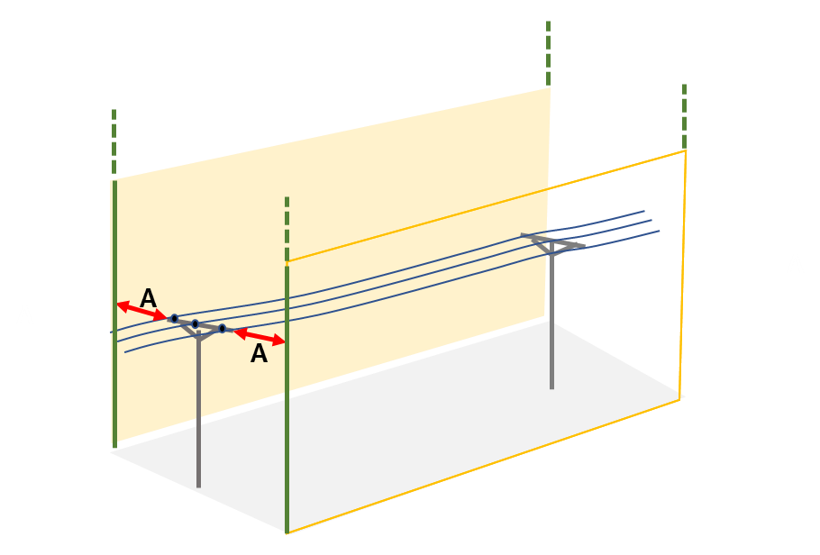
Figure 4.1 Illustration of Hazard Zone.
The minimum horizontal distance of the Hazard Zone (A) shall be:
- 6.0 m for 0 to 33kV OHL
- 10.0 m for OHL over 33kV
NOTE on sub-clause 4.2.1:
- For plant and machinery, the Hazard Zone shall be the Hazard Zone values above plus the distance measured from the horizontal falling distance of a fully extended boom of plant or machinery. See Figure 4.2 for illustration.
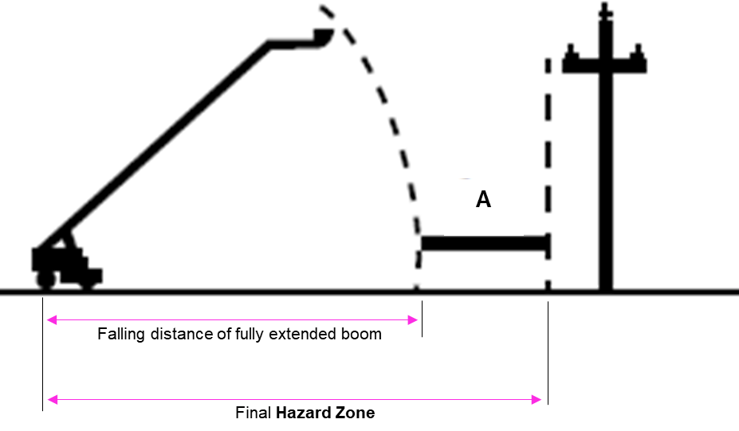
Figure 4.2: Illustration of Hazard Zone for plant and machinery.

    - Exclusion Zone
This is a region around a live OHL which must never be breached in order to avoid electrical arcing or flashover. Figure 4.3 is an illustration of the Exclusion Zone (R) around three conductors of an OHL on a single pole.
The minimum Exclusion Zone shall be:
- 1.0 m for 0 to 1kV OHL, insulated type
- 3.0 m for 0 to 1kV OHL, bare type
- 3.0 m for 11kV to 33kV OHL
- 3.3 m for 66kV OHL
- 3.6 m for 88kV OHL
- 4.7 m for 132kV OHL
- 6.0 m for 220kV OHL
- 7.3 m for 330kV OHL
NOTE on sub-clause 4.2.2:
- For insulated OHL, personnel working around OHL shall verify insulation integrity with the licensee owning the OHL, before any work starts. This shall be responsibility of Project Supervisor of Works.
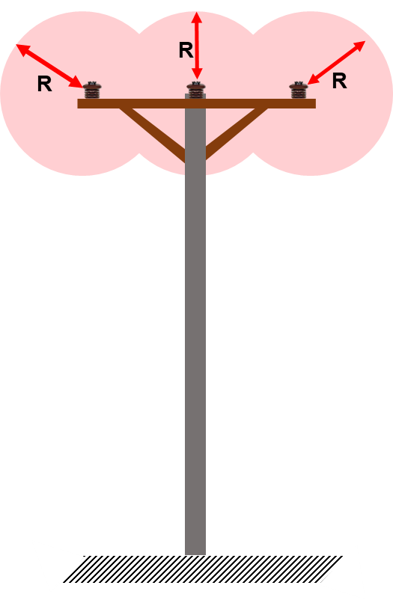
Figure 4.3: Illustration of Exclusion Zone.

    - No-tip Zone
This is a space that no part of a tipped truck or other raised equipment must enter. A No-tip Zone applies to road strengthening and resurfacing works such as tarring and chipping existing roads.
    - Crossing Point
A Crossing Point is a defined, protected corridor that crosses under an OHL. Crossing Points shall be created by installing:
- Goalpost-style height-restricting barriers; and
- Warning signs for overhead lines at entrances and exits of the crossing point.
There shall be created Crossing Points for the purposes of:
- Limiting the location and the height of plant and machinery that can cross under the OHL; and
- Alerting drivers and plant operators to the hazard of the OHL before they cross under it. Figure 6 in section 4.3 illustrates a crossing point.
  - Safety distances to maintain on sites where there will be no work or plant passing in or under the Hazard Zone
NOTE: In sites covered under this clause, plant or machinery may accidentally enter the Hazard Zone. Therefore:
    - Barriers shall always be erected on the work side (outside the edge of the Hazard Zone) at the correct distance from the line, as illustrated in Figure 4.4 below.
    - The barrier materials (bunting, uprights and goalposts) shall be of strong and sturdy, non-conducting and clearly visible materials, as illustrated in in Figure 4.4 below.
    - As further illustrated in Figure 4.4, standard electricity hazard warning signs shall be put along the route at intervals of 20 meters or less.
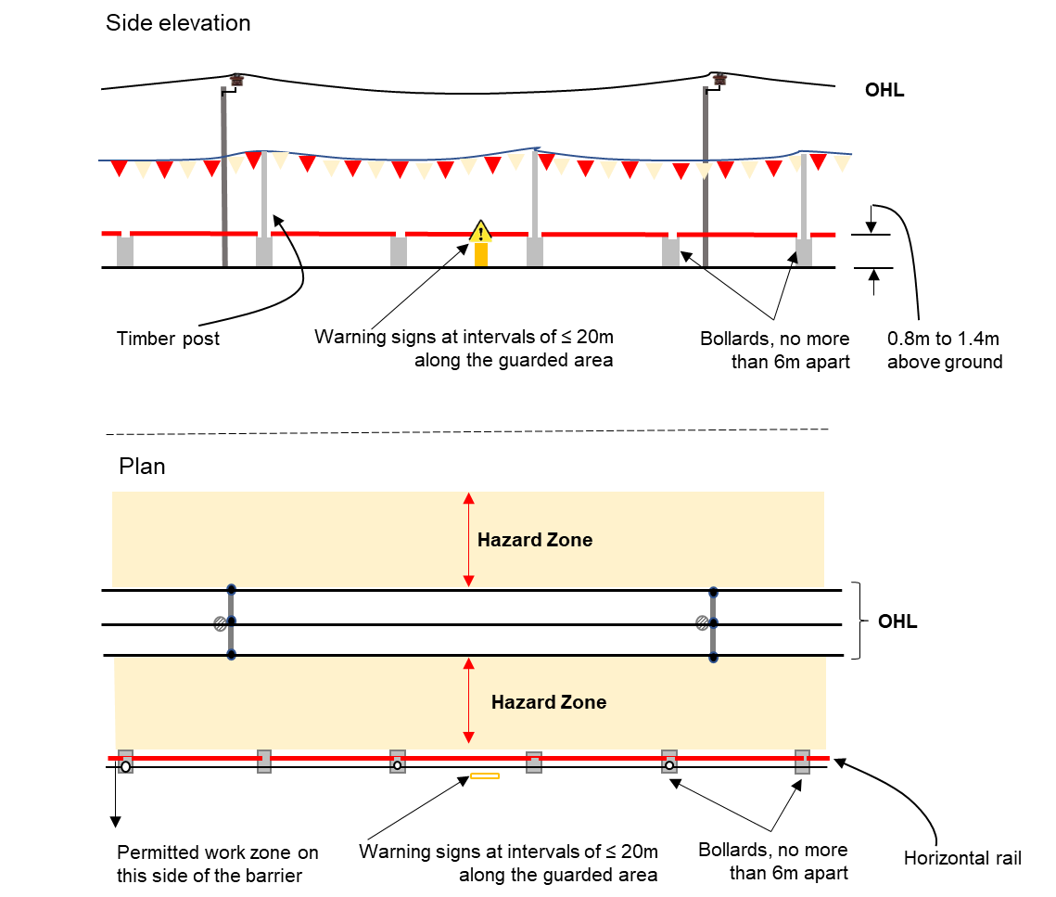
Figure 4.4: Illustration – Elevation and plan for a site where plant and machinery will not pass under OHL.
  - Safety distances to maintain on sites where plant and machinery will pass under a live OHL
    - When there is need to move plant and machinery under a live OHL, there shall be created Crossing Points which shall be erected from height-restricting goalposts. The goalposts shall be made from rigid, non-conducting, clearly visible material at the entrance to the Crossing Point on each side of the line. Figure 4.5 illustrates the correct design of a Crossing Point.
    - The maximum height of the Crossing Point outside the Hazard Zone and in line with the protection barriers shall be 4.2 m, measured relative to ground level of the original site
    - The maximum width of the Crossing Point outside the Hazard Zone and in line with the protection barriers shall be 9.0 m, measured relative to ground level of the original site.
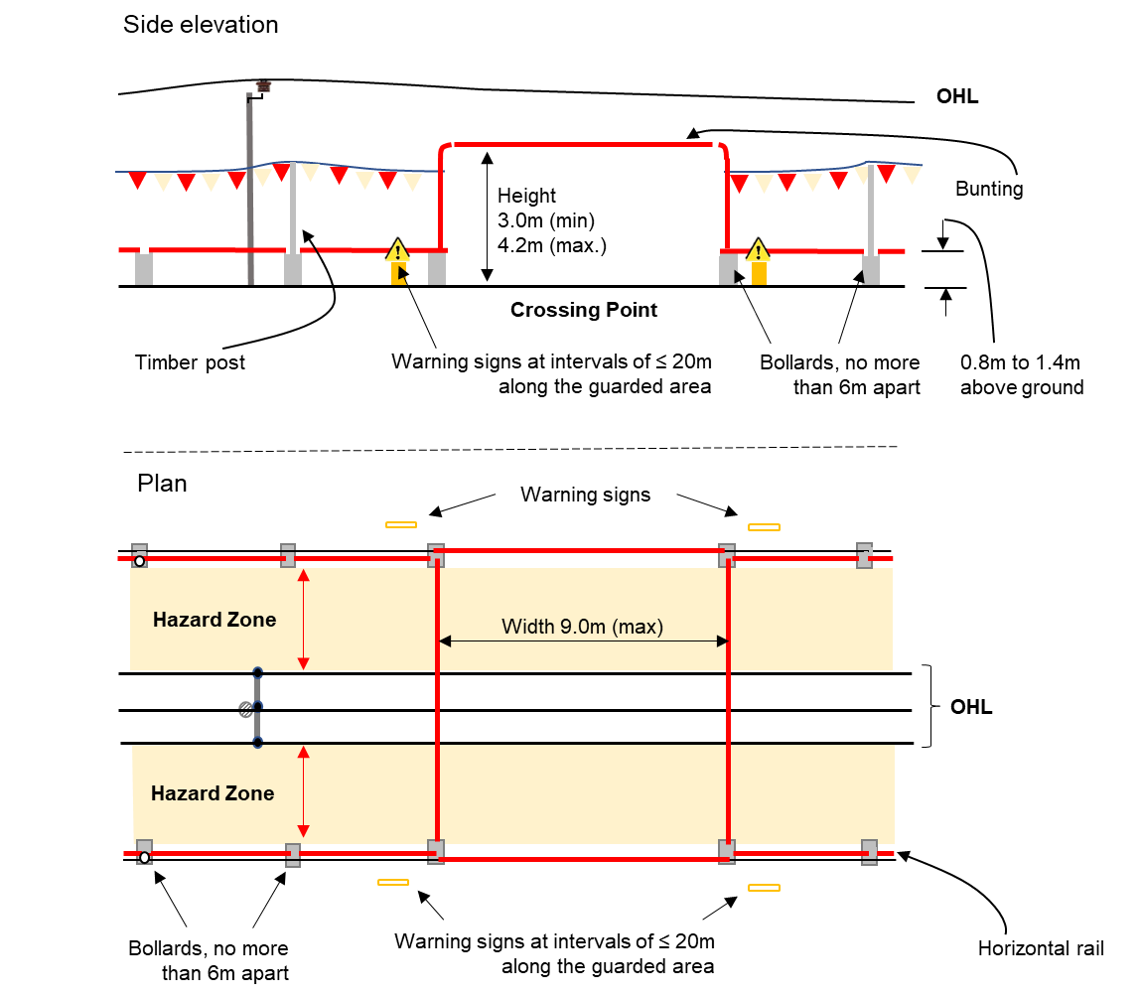
Figure 4.5: Illustration – Elevation and plan for a site where plant and machinery need to pass under OHL.
  - Safety distances to maintain on sites where work will be carried out in the Hazard Zone
    - In certain very limited circumstances, work in the Hazard Zone of live OHL, including the use of specified equipment, may be permitted by the OHL network owner or operator, but the responsibility for safety remains with the works supervisor.
    - In all cases, before work begins, the site- or works-supervisor shall fulfill the following:
- Verification of the line Voltage with the Licensee owning the OHL;
- Determination of the Hazard Zone; and,
- Determination of the Exclusion Zone
    - Determination, preparation and implementation of a site and job-specific risk assessment and work method statement which shall cover the following:
- The vertical Clearance of the closest conductor of the OHL, taking into account any possible sag
- The maximum potential height that the equipment can reach, ignoring any mechanical, electronic or electromechanical height limiters that are or may be fitted to the equipment
- The possible effect on the vertical Clearance of OHL as a result of changing or varying ground levels within the Hazard Zone due to the intended specific work
- The possible effect on the OHL support structures as a result of the intended specific work.
  - Safety Clearances to maintain when performing road strengthening and resurfacing works near OHL
    - During road strengthening or resurfacing works, the Works Supervisor shall establish and maintain a No-tip Zone with a minimum Lateral Clearance of 3.0 meters from the closest conductor of OHL. Warning signs shall be placed at the entrance and exits of the No-tip Zone.
    - For visual guidance on placing these signs and how to determine the correct No-tip Zone when the road crosses the OHL lines at 90 degrees, more than 45 degrees and less than 45 degrees, see Figures 4.6 to 4.8, respectively.
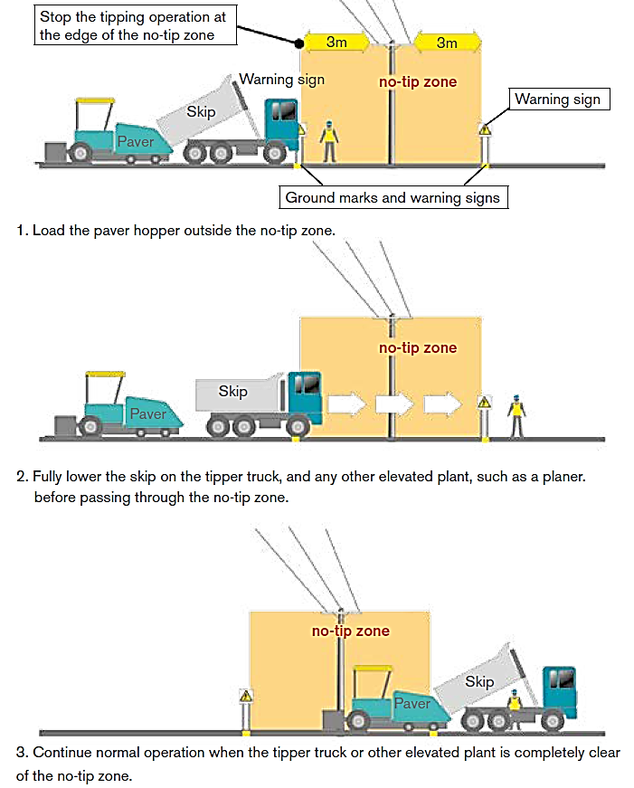
Figure 4.6: Illustration – Determining the No-tip Zone and safe system of work when OHL crosses the road at 90 degrees.
(source: Electricity Supply Board Ireland (2019))
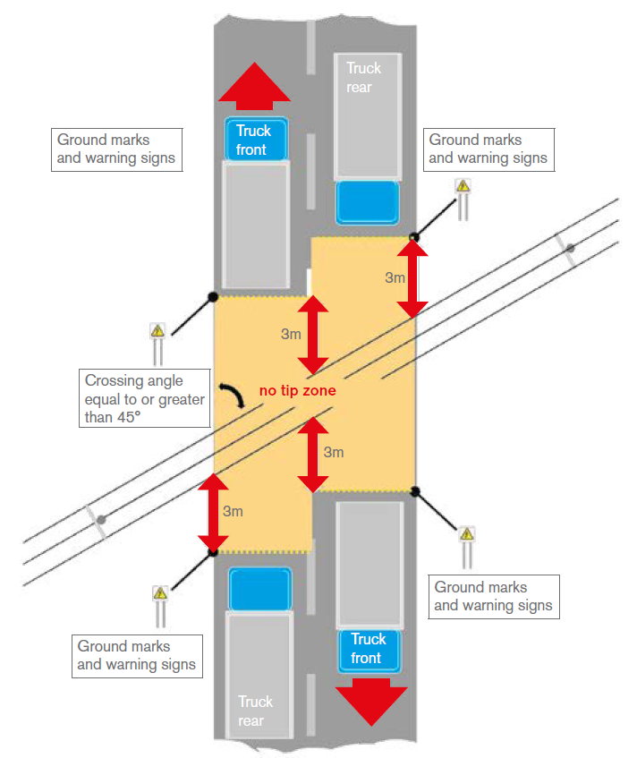
Figure 4.7: Illustration – Determining the No-tip Zone and safe system of work when OHL crosses the road at an angle equal to or greater than 45 degrees.
(source: Electricity Supply Board Ireland, (2019))
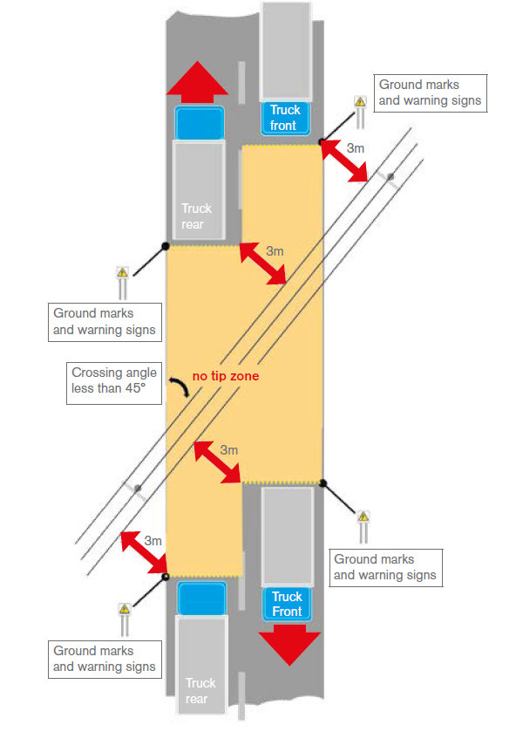
Figure 4.8: Illustration – Determining the No-tip Zone and safe system of work when OHL crosses the road at an angle equal to or less than 45 degrees.
(source: Electricity Supply Board Ireland, (2019))

MINIMUM CLEARANCES FROM UNDERGROUND ELECTRICITY CABLES UP TO 33KV
  - Introduction to Section 5
    - Underground electric cables shall be installed having regard to system reliability, ease of future maintenance, safety and consideration to minimize damage to underground assets.
    - Safe design principles should apply to the installation process to ensure that operational and safety risks are adequately assessed and addressed.
  - Depth of cover for underground electric cables
    - For open trench construction, the depth of cover shall not be less than:
- 0.75 m below the surface of a roadway, for any cable installed under a roadway; and,
- 0.60 m below the finished ground surface, for cables installed in other locations.
NOTE on sub-clause 5.2.1:
- Where physical obstructions, such as other utility services, make it impossible to achieve these depths, additional mechanical protection must be provided by means of a minimum cover of 100mm of 20 MPa concrete or equivalent.
- Any additional mechanical protection should be marked by embossing the words ‘ELECTRIC CABLE’ or similar, along its length.
    - For direct buried cable installation construction, the depth of cover shall not be less than 0.90 m below the finished ground surface.
NOTE on sub-clause 5.2.2:
- Clause 5.5.2 does not apply to that part of an underground cable entering or leaving the ground vertically or fixed above the ground to a secure structure, as long as adequate mechanical protection is provided.
  - Laying of cables
    - Underground cables shall be installed using the techniques that shall ensure that damage to the cables is negligible. Consideration shall be given to:
- Maximum hauling tensions;
- Minimum bending and setting radii;
- Cable side wall pressures; and
- Cable abrasion avoidance.
  - Minimum vertical clearances to electricity underground cables
    - General
      - When determining the minimum separation from other underground utility services with the same route, a Utility wishing to install their underground utility service must consult with any and all the other existing Utility(ies) sharing the underground route or trench, bearing in mind:
- Worker and public safety
- Potential cable damage due to failure of other services
- Future access for repairs/maintenance.
      - Notwithstanding the aforesaid, the clearance from the centre of most adjacent direct buried underground cable installations, or if available, the most adjacent surface of electric cable trenching, to other utility service assets shall not be less than the minimum clearances specified in this Code.
    - Vertical clearances to other non-electricity utilities
The vertical minimum clearances specified in Table 5.1 shall be maintained where other utility service assets are required to be installed vertically parallel, crossing over or under the electricity utility underground assets. The physical arrangements are illustrated in figure 5.1 below.
Table 5.1 Minimum vertical clearances from Licensee underground electricity cables to other utility services
Service type |  |  | Minimum vertical clearance to underground service of Voltage, V:
 |  |  | V ≤ 400 volts | 400 < V ≤ 33kV
Telecommunication services (piped) |  |  | 0.100 m | 0.300 m
Telecommunication services (pit) |  |  | 0.100 m | 0.100 m
Sewer Mains – Public/private (e.g., sanitary drainage pipe system) |  | Pipe dia. (DN≤300) | 0.225 m | 0.225 m
 |  | Pipe dia. (DN>300) | 0.300 m | 0.300 m
Water Service Line – Public/Private | Parallel mechanically protected (see Note 1) | Pipe dia. (DN≤65) | 0.100 m | 0.100 m
 |  | Pipe dia. (DN>65) | 0.300 m | 0.300 m
 | Parallel (unprotected) |  | 0.600 m | 0.600 m
 | LV earthing |  | 0.500 m | EUA (see Note 4)
Storm Water – Public/Private | Parallel (protected) (see Notes 1 & 3) |  | 0.100 m | 0.100 m
 | Parallel (unprotected) (see Note 3) |  | 0.600 m | 0.600 m
 | Crossing (see Note 2) |  | 0.100 m | 0.100 m
Public Lighting Wiring-from customer ckt or metered supply point |  |  | 0.100 m | 0.300 m
Customer underground LV mains |  |  | 0.100 m | 0.300 m
NOTES to Table 5.1:
- Mechanical protection (e.g., by the concrete slabs, continuous pour, bricks designed for protecting etc) for the electrical supply cables.
- The minimum vertical separation between any underground storm water drain crossing an underground electric distribution service cable shall:
a) Cross at angle 90° if practicable, but not less than 45°;
b) Have a vertical separation of not less than 100mm; and
c) Be marked along its length for 1,000mm either side of the center line of the service, with marker tape, laid 150mm above the installed service.
- The minimum horizontal separation between any underground storm water drain and an electrical distribution service cable shall be at least:
a) 100mm provided the electrical cable is indicated along its length with orange marker tape specified in this code, and is mechanically protected; or
b) 600mm, where the electrical supply cable is not mechanically protected.
- EUA refers to requirement that approval of the actually required clearance must be obtained from the Electricity Licensee owning the underground cable.
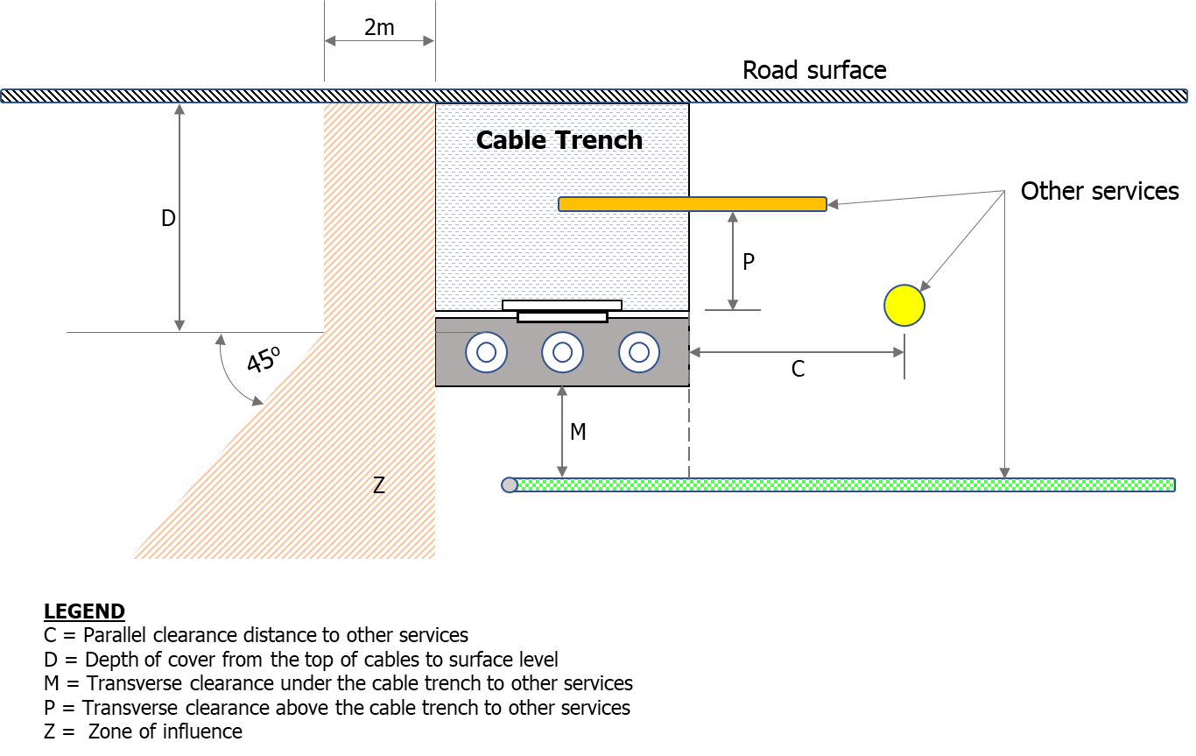
Figure 5.1: Clearances from underground electricity cables and trenching to other Utility services.
  - Minimum horizontal clearances to other non-electricity utility service lines
    - The horizontal minimum clearances specified in Table 5.2 shall be maintained where other utility service assets are required to be installed vertically parallel, crossing over or under the electricity utility underground cables. These minimum clearances shall be observed and maintained by all Utility(ies) whenever their service lines are routed underground.

Table 5.2 Minimum horizontal clearances from Electricity Licensee underground cables to other utility services
Service type |  |  | Minimum horizontal clearance to underground cable of Voltage, V:
 |  |  | V ≤ 400 volts | 400 < V ≤ 33kV
Telecommunication services (piped) |  |  | 0.100 m | 0.300 m
Telecommunication services (pit) |  |  | 0.100 m | 0.100 m
Sewer Mains – Public/private (e.g., sanitary drainage pipe system) |  | Pipe dia. (DN≤300) | 0.500 m | 0.500 m
 |  | Pipe dia. (DN>300) | 1.000 m | 1.000 m
Water Service Line – Public/Private | Parallel mechanically protected (see Note 1) | Pipe dia. (DN≤65) | 0.100 m | 0.100 m
 |  | Pipe dia. (DN>65) | 0.300 m | 0.300 m
 | Parallel (unprotected) |  | 0.600 m | 0.600 m
 | LV earthing |  | 0.500 m | EUA (see Note 4)
Storm Water – Public/Private | Parallel (protected) (see Notes 1 & 3) |  | 0.100 m | 0.100 m
 | Parallel (unprotected) (see Note 3) |  | 0.600 m | 0.600 m
 | Crossing (see Note 2) |  | 0.100 m | 0.100 m
Water Mains – Public/Private | For water pipe dia. ≤ 200 |  | 0.500 m | 0.500 m
 | Other water mains |  | 1.000 m | 1.000 m
Public Lighting Wiring - from customer ckt or metered supply pt. |  |  | 0.100 m | 0.300 m
Customer underground LV mains |  |  | 0.100 m | 0.300 m
Road side kerb |  |  | 0.800 m | 0.800 m
NOTES to Table 5.2: (same as Notes to Table 5.1).
  - Minimum clearance from underground electricity cables to buildings
    - The minimum clearances to be maintained between the foundation of a building or a structure and the underground electric cables (measured from the centre of the most adjacent cable, or if available, the most adjacent surface of the cable trench) shall be 2.0 m. This requirement is illustrated in figure 5.2 below.
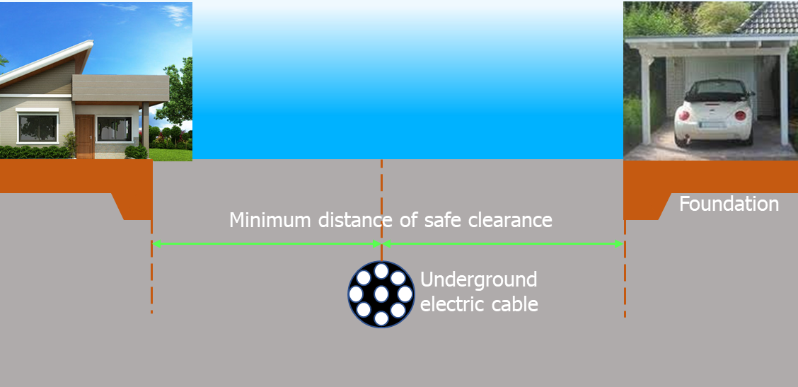
Figure 5.2 Minimum safety clearance of underground cables from building structures
  - Clearance from underground electricity cable to fire hydrants external to buildings
    - The minimum lateral clearance to be maintained between foundation a fire hydrant system which is located external to a building and an underground electricity cable shall be 10 meters.
  - Clearance from underground electricity cable to tank or tank farm used for storage of flammable substances
    - The minimum Lateral clearance from an underground electricity cable (measured from the centre of the most adjacent cable) to the closest edge of concrete bedding or foundation of a tank or tank farm used for storage of flammable substances defined as Class 0, Class I, Class II or Class III in ZS 402: 2006, shall be:
- 4.0 m for a tank or tank farm of capacity is 2,000 liters or less
- 5.0 m for a tank or tank farm whose capacity is over 2,000 liters, but less than or equal to 4,000 liters
- 6.0 m for a tank or tank farm whose capacity is over 4,000 liters, but less than or equal to 7,000 liters
- 7.0 m for a tank or tank farm whose capacity is over 7,000 liters, but less than or equal to 10,000 liters
- 8.0 m for a tank or tank farm whose capacity is over 10,000 liters, but less than or equal to 25,000 liters
- 9.0 m for a tank or tank farm whose capacity is over 25,000 liters, but less than or equal 50,000 liters
- 12.0 m for a tank or tank farm whose capacity is more than 50,000 liters, but less or equal to 200,000 liters
- 15.0 m for a tank or tank farm whose capacity is over 200,000 liters.
Refer to figure 5.3 for illustration.
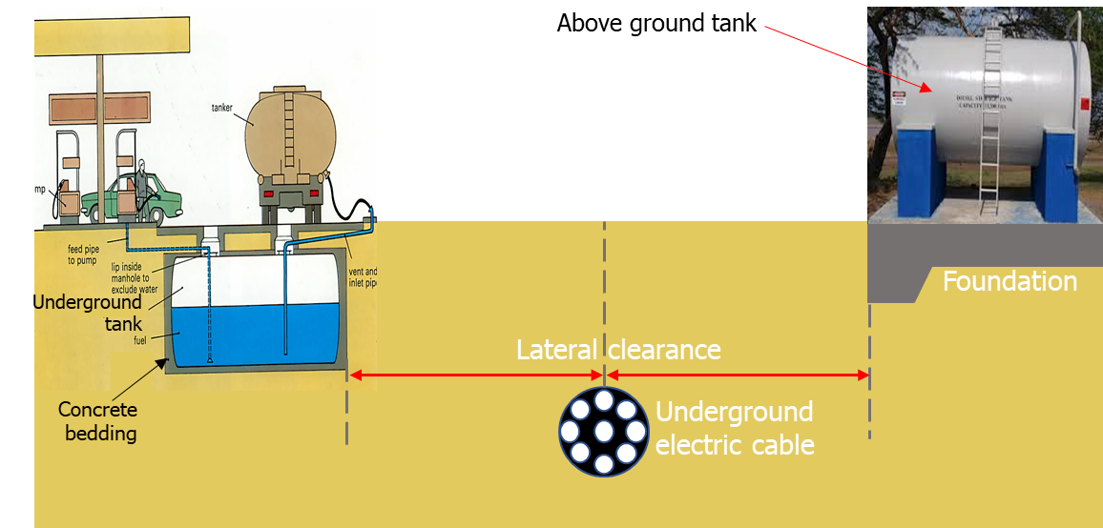
Figure 5.3 Illustration of minimum safety clearance distance of underground electricity cables from bulk flammable liquid storage tanks
  - Growth Limit Zone of tree roots near underground electricity cables
    - Any person wishing to dig the ground for the purposes of planting a tree or trees shall ensure they know exactly where all underground cables are, and shall not dig holes within 4 metres of the most adjacent existing underground cable(s)
    - Tree owners shall be responsible for keeping their tree roots clear of electric underground cables
    - As illustrated in figure 5.4 below, the Growth Limit Zone, that is, the minimum distance which the roots of a tree must be kept away from an underground electricity cable, shall be 0.50 m.
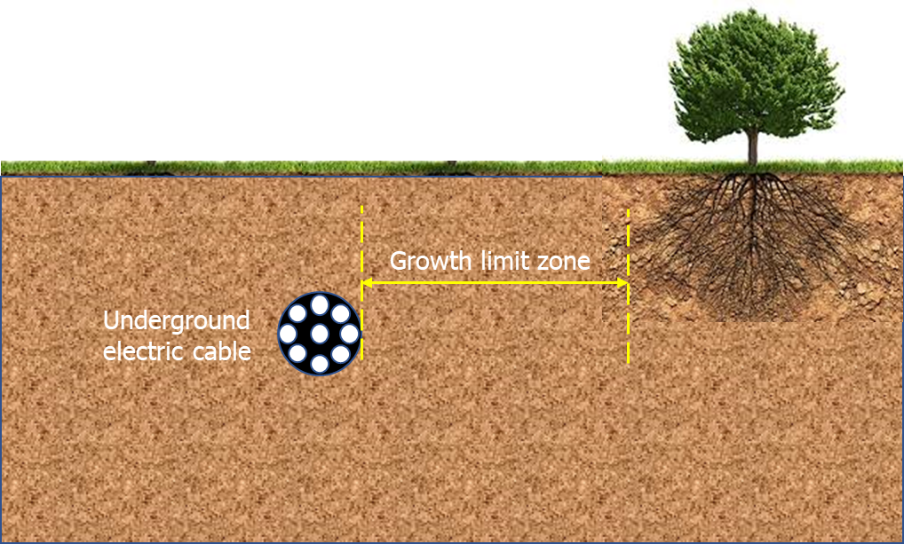
Figure 5.4 Illustration of Growth Limit Zone near underground electric cable.

REFERENCES
Electricity Supply Board Ireland (2019), Code of Practice for Avoiding Danger from Overhead Electricity Lines. 2nd edn. ESB Networks, United Kingdom.
Endeavour Energy (2011), Where to draw the line on Safety Clearances from Electricity Assets. Endeavour Energy, NSW, Australia.
ESKOM Distribution (2011), Distribution Guide – Part 19: Building Line Restrictions, Servitude widths, Line Separations and Clearances from Power Lines. ESKOM, South Africa.
National Electric Safety Code (2007), IEEE C2: National Electrical Code (2007). 7th edn. Institute of Electrical and Electronics Engineering, Inc.
National Grid Plc (2016), Third-party guidance for working near National Grid Electricity Transmission equipment. National Grid, United Kingdom.
Government of South Australia (2015), Building safely near power lines. Office of the Technical Regulator, Australia.
SA Power Networks (2020), Technical Standard - TS085 Trenching and Installation of Underground Conduits and Cables (up to and including 33kV). SA Power Networks, Australia.
TransGrid (n.d), Requirements for working in the vicinity of TransGrid Underground Cables. TransGrid, Australia.

